STORM WATER POLLUTION PREVENTION PLAN (SWPPP)
Project Title: [ADD PROJECT TITLE]
Project No.: [ADD PROJECT NO.]
NPDES Permit No.: [ADD PERMIT NO.]
Prepared by: [ADD Contractor Name]
Date: [ADD Current Date]

Storm Water Pollution Prevention Plan (SWPPP)
Preparation Date: XX/XX/XXXX

Table of Contents
Table of Contents 2
7.0 Preface 4
7.0.1 Notes for Contractor/ Construction Personnel 4
7.2.1 Storm Water Team 4
7.2.2 Nature of Construction Activities Form C.6 6
7.2.3 Emergency Related Projects 7
7.2.4 Identification of Prime Contractor and Other Site Contractors 7
7.2.5 Sequence and Estimated Dates of Construction Activities 10
7.2.6.1 Property Boundary and BMP Maps 10
7.2.6.2 to 7.2.6.8 State Waters and BMP Maps 12
7.2.7 Construction Site Pollutants 14
7.2.8 –Sources of Non-Storm Water 17
7.2.9 –Buffer Documentation 21
7.2.10 Storm Water Control Measures 23
BMP Details 23
7.2.10.2 – Stabilization Practices 44
7.2.10.3 – Post Construction Measures 46
7.2.11.1 – Spill Prevention and Response Procedures 46
7.2.11.2 – Waste Management Procedures 47
7.2.12 – Procedures for Inspection, Maintenance, and Corrective Action 48
7.2.13 – Staff Training 49
7.2.14 – Documentation of Compliance with Safe Drinking Water Act Underground Injection Control (UIC) Requirements for Certain Subsurface Storm Water Controls 50
7.2.15 –Other State, Federal, or County Permits 51
7.2.16 –Other Information As Requested by the Director 51
7.2.17 Certification of the SWPPP 52
7.2.18 Post-Authorization Additions to the SWPPP 53
7.4 Required SWPPP Modifications 53
13.0 Monthly Compliance Report Submittal Requirements 54
SWPPP Attachments 55
Attachment A – Contractor/Sub-Contractor Control Maps, Property Boundary Maps, State Waters and BMP Maps, and BMP Details (SWPPP Sections 7.2.4, 7.2.6.1,7.2.6.2 to 7.2.6.8 & 7.2.10) 55
Attachment B – SWPPP Training Log (SWPPP Section 7.2.13) 56
Attachment C - Construction Schedule (SWPPP Section 7.2.5) 58
Attachment D – Subcontractor Certifications/Agreements (SWPPP Section 7.2.4) 59
Attachment E1 – SWPPP Inspection Report Form (SWPPP Section 7.2.12) Rev. 1/28/2015 60
Attachment E2 – Corrective Action Reports (SWPPP Section 7.2.12) 64
Attachment E3 – Construction Discharge Report Form (SWPPP Section 7.2.12) 67
Attachment E4 – Monthly Compliance Report 75
Attachment F – Spill Prevention and Response Procedures (SWPPP Section 7.2.11.1) 78
Attachment G – Waste Management Procedures (SWPPP Section 7.2.11.2) 82
Attachment H – Contingency Plan 86
Attachment I – SWPPP Amendment Log 88
Attachment J – Emergency Related Projects, Departures from Manufacturer’s Specifications for Fertilizers Containing Nitrogen or Phosphorus, Buffer Documentation, Documentation of Compliance with UIC Requirements, Other State/Federal/County Permits, & Other Information as Requested by the Director (SWPPP Sections 7.2.3, 7.2.9, 7.2.14, 7.2.15, and 7.2.16) 89
Attachment K – Post-Authorization Additions to the SWPPP 90

7.0 Preface
The following documents are referenced throughout this document:
- Hawaii Administrative Rules (HAR), Chapter 11-55 (used as a guideline for the Sections)
- City and County of Honolulu, Storm Water Best Management Practice Manual
- Standard Specifications and Special Provisions
- City & County of Honolulu, Rules Relating to Soil Erosion Standards & Guidelines

7.0.1 Notes for Contractor/ Construction Personnel
NOTE: Currently, the project does not have an NPDES Permit to authorize discharges of storm water associated with construction activity.
The Contractor shall keep track of the total disturbed area. If the area is one acre or more, it will trigger an NPDES Permit.
Total Disturbed Area (including Staging Areas) = XX Acres
- Construction BMPs shall be inspected weekly, and within 24 hours of any rainfall event of 0.25 inches or greater in a 24 hour period and daily during periods of prolonged rainfall. For more details, see Section 7.2.12 of this SWPPP.
- Immediately initiate and complete stabilization within 7 calendar days on areas of the site in which earth-disturbing activities have temporarily or permanently ceased. For more details, see Section 7.2.10.2 of this SWPPP.

7.2.1 Storm Water Team
The permittee shall assemble and oversee a “storm water team,” which is responsible for the development of the SWPPP, any later modifications to it, and for compliance with the BMP requirements for this project.
{The Contractor shall include their personnel information once the project is awarded.}
1) Name:Company: Contractor
Position:
Contact Number: (808) xxx-xxxx Responsibilities: Developed the SWPPP

- Name:
Company:
Position: Construction Project Engineer
Contact Number: (808) xxx-xxxx
Responsibilities: Responsible for overall project and field compliance with the project requirements, including SWPPP and any required modifications to SWPPP
- Name:
Company: Contractor
Position: Inspector
Contact Number: (808) xxx-xxxx
Responsibilities: Responsible for BMP inspections and verifying implementation of BMPs in the field
- Name:
Company: Contractor
Position: (FILL IN Contractor Designated Representative)
Contact Number: (808) xxx-xxxx
Responsibilities: Responsible for overall project and field compliance and BMP inspections

- Name:
Company: Contractor
Position: (FILL IN Contractor Designated Representative)
Contact Number: (808) xxx-xxxx
Responsibilities: Responsible to develop and maintain updates and modifications of to the
SWPPP

- Name: __________________________________________________________________
Company: Contractor
Position: Contractor
Contact Number: (808) xxx-xxxx
Responsibilities:
- Name:
Company: Contractor
Position: Contractor
Contact Number: (808) xxx-xxxx
Responsibilities:

7.2.2 Nature of Construction Activities Form C.6

What is the function of the construction activity (Please check all applicable activity(ies))?
☐ Residential ☐ Commercial ☐ Industrial ☐ Road Construction ☐ Linear Utility
☐ Other (please specify):
For construction site estimates, see NOI Form C, Section C.3 – Construction Site Estimates,
Attachment A-4

What is being constructed? [ADD DESCRIPTION] Describe the scope of work and major construction activities for the project, including baseyards and staging areas. Include only project areas where the locations of impervious structures are known; project areas where the final grades are known; and work areas that will be performed by one (1) general contractor. (Note: Per the Contract Documents, the maximum surface area of earth material which may be exposed at any time is 300,000 square feet.)

The scope of work for this project includes [ADD DESCRIPTION]
{The locations of the staging and storage areas (Construction Operating Support Area [COSA] may be changed by the Contractor depending on his construction means and methods. The Contractor shall submit to the Engineer the locations of his COSA(s) once the project is awarded for review and acceptance. Note that all COSA locations must be included on the BMP map attachment of this SWPPP. Details including, locations of chemical/HAZMAT storage, spill kit, contractor vehicles parking, heavy equipment storage, construction materials storage, dirt, spoils, and other material stockpiles, and all associated BMPs [i.e., stabilized construction entrance, secondary containment, stockpile BMPs, etc.] must be indicated and may be included as graphics on separate page attachment(s) as needed}.

7.2.3 Emergency Related Projects

Check as applicable:
☐ Not Applicable
☐ Applicable (If this box is checked, provide additional information as described below)
If conducting earth-disturbing activities in response to a public emergency (see Section 1.3.), the permittee shall document the cause of the public emergency (e.g., natural disaster, extreme flooding conditions, etc.), information substantiating its occurrence (e.g., state disaster declaration or similar state declaration), and a description of the construction necessary to reestablish effected public services. The declaration of emergency or imminent threat to public health is required to be from the state governor or the director. See Attachment J for additional information.

7.2.4 Identification of Prime Contractor and Other Site Contractors
Here is a list of both the prime contractor and all other contractors (e.g., sub-contractors) who will be engaged in construction activities at the site, and the areas of the site over which each contractor has control. {List prime contractor and sub-contractors below and attach map showing areas of control in Attachment A. Complete and attach a Signed Subcontractor Certification/Agreement in Attachment D.}
General Contractor Company Name: [ADD GENERAL CONTRACTOR INFORMATION]
General Contractor Contact Person Name:
General Contractor Mailing Address:
General Contractor Mailing City: | Mailing State and Zip Code:
General Contractor Telephone Number: (808)
General Contractor Email Address:

Sub-Contractor #1 Company Name: [ADD SUB-CONTRACTOR INFO]
Sub-Contractor Contact Person Name:
Sub-Contractor Mailing Address:
Sub-Contractor Mailing City: | Sub-Contractor Mailing State and Zip Code:
Sub-Contractor Telephone Number: (808)
Sub-Contractor Email Address:

Sub-Contractor #2 Company Name:
Sub-Contractor Contact Person Name:
Sub-Contractor Mailing Address
Sub-Contractor Mailing City: | Sub-Contractor Mailing State and Zip Code:
Sub-Contractor Telephone Number: (808)
Sub-Contractor Email Address:

Sub-Contractor #3 Company Name, as needed:
Sub-Contractor Contact Person Name:
Sub-Contractor Mailing Address:
Sub-Contractor Mailing City: | Sub-Contractor Mailing State and Zip Code:
Sub-Contractor Telephone Number: (808)
Sub-Contractor Email Address:

Sub-Contractor #4 Company Name:
Sub-Contractor Contact Person Name:
Sub-Contractor Mailing Address:
Sub-Contractor Mailing City: | Sub-Contractor Mailing State and Zip Code:
Sub-Contractor Telephone Number: (808)
Sub-Contractor Email Address:

Sub-Contractor #5 Company Name:
Sub-Contractor Contact Person Name:
Sub-Contractor Mailing Address:
Sub-Contractor Mailing City: | Sub-Contractor Mailing State and Zip Code:
Sub-Contractor Telephone Number: (808)
Sub-Contractor Email Address:

Sub-Contractor #6 Company Name:
Sub-Contractor Contact Person Name:
Sub-Contractor Mailing Address:
Sub-Contractor Mailing City: | Sub-Contractor Mailing State and Zip Code:
Sub-Contractor Telephone Number: (808)
Sub-Contractor Email Address:

Sub-Contractor #7 Company Name:
Sub-Contractor Contact Person Name:
Sub-Contractor Mailing Address:
Sub-Contractor Mailing City: | Sub-Contractor Mailing State and Zip Code:
(Sub-Contractor Telephone Number) (808)
(Sub-Contractor Email Address)

Complete the following items and include them in the Attachments:
    Attach maps showing areas of Contractor/Subcontractor Control in Attachment A.

❑ Complete and attach a Subcontractor Certification/Agreement in Attachment D.

7.2.5 Sequence and Estimated Dates of Construction Activities

❑ Insert the proposed construction schedule here, which shall include, at a minimum the items below. Use specific dates.

{The Contractor shall submit to the Engineer an update of the dates in the SWPPP once the project is awarded.}

- Installation of storm water control measures, and when they will be made operational, including the sequence and schedule for installation of storm water control measures and of any departures from manufacturer specifications, including removal procedures of the storm water control measures after construction has ceased.

- Commencement and duration of earth-disturbing activities, including clearing and grubbing, mass grading, site preparation (i.e., excavating, cutting and filling), final grading, and creation of soil and vegetation stockpiles requiring stabilization.

- Cessation, temporarily or permanently, of construction activities on the site, or in designated portions of the site.

- Final or temporary stabilization of areas of exposed soil.

- Removal of temporary storm water conveyances/channels and other storm water control measures, removal of construction equipment and vehicles, and cessation of any pollutant-generating activities.

7.2.6.1 Property Boundary and BMP Maps

Complete the following and include in Attachment A:

❑ Include Property Boundary Maps showing the boundaries of the property, the locations where construction activities will occur, and all associated BMPs to be used. Attach, title, and identify all maps (pdf - minimum 300 dpi) listed below, in Attachment A.

- Legal boundaries of the project. See SWPPP Attachment A-??

- Locations where earth-disturbing activities will occur, noting any sequencing of construction activities. See SWPPP Attachment A-??

- Pre-Construction Topography including approximate slopes and drainage patterns for the entire Facility/Project site to the receiving storm water drainage system (if applicable) or to the receiving State water(s) (with flow arrows). Note areas of steep slopes (15% or greater in grade). See SWPPP Attachment A-??

- During-Construction Topography (after major grading activities) including approximate slopes and drainage patterns for the entire Facility/Project site to the receiving storm water drainage system (if applicable) or to the receiving State water(s) (with flow arrows) Note areas of steep slopes (15% or greater in grade). See SWPPP Attachment A-??

- Post-Construction Topography including approximate slopes and drainage patterns for the entire Facility/Project site to the receiving storm water drainage system (if applicable) or to
the receiving State water(s) (with flow arrows). Note areas of steep slopes (15% or greater in grade).

- Locations where sediment, soil, or other construction materials will be stockpiled, and their associated BMPs.
See SWPPP Attachment A-??. Stockpile locations may be changed by the Contractor depending on his construction means and methods. The Contractor shall submit to the Engineer for his review and acceptance any updates/changes to stockpile areas during construction for inclusion in the SWPPP.

- Locations of any contaminated soil or contaminated soil stockpiles, if applicable.

- Locations of any crossings of state waters 7.2.6.1e. See SWPPP Attachment A-??

- Designated points on the site where vehicles will exit onto paved roads 7.2.6.1f. See SWPPP Attachment A-??. Stabilized entrance locations may be changed by the Contractor depending on his construction means and methods. The Contractor shall submit to the Engineer for his review and acceptance any updates/changes to stabilized entrances during construction for inclusion in the SWPPP.

- Location(s) of impervious structures (including buildings, roads, parking lots, etc.) after construction is completed 7.2.6.1g.

- Locations of construction operation support areas (COSAs) covered by this permit 7.2.6.1h. Locations of chemical/HAZMAT storage, spill kits, contractor vehicles parking, heavy equipment storage, construction materials storage, dirt, spoils, and other material stockpiles, and all associated BMPs (i.e., stabilized construction entrance, secondary containment, stockpile BMPs, etc.) within COSAs shall be included. See SWPPP Attachment A-??. The locations of the staging and storage areas may be changed by the Contractor depending on his construction means and methods. The Contractor shall submit to the Engineer any updates/changes to staging and storage areas during construction for his review and acceptance and inclusion in the SWPPP.

7.2.6.2 to 7.2.6.8 State Waters and BMP Maps

Complete the following items:

- Attach, title, and identify all maps (pdf - minimum 300 dpi) listed below, in Attachment A.
- Reference which maps account for the features listed below.
- Locations of all state waters, including wetlands that exist within or in the immediate vicinity of the site and indicate which waterbodies are listed as impaired 7.2.6.2. See SWPPP Attachment A-??

- The boundary lines of any natural buffers provided consistent with Section 5.1.2.1.1, 7.2.6.3. See Section 7.2.9 – Buffer Documentation

- Topography of the site, existing vegetative cover (e.g., forest, pasture, pavement, structures), and drainage pattern(s) of storm water onto, over, and from the site property before and after major grading activities 7.2.6.4. See SWPPP Attachment A-??

- Storm water discharge locations, including: a) Locations of any storm drain inlets on the site and in the immediate vicinity of the site to receive storm water runoff from the project; See SWPPP
Attachment A-??
and b) Locations where storm water will be discharged to state waters (including wetlands) 7.2.6.5. See SWPPP Attachment A-??

- Locations of all potential pollutant-generating activities identified in Section 7.2.7, 7.2.6.6.
See SWPPP Attachment A-??

- Locations of storm water control measures 7.2.6.7. See SWPPP Attachment A-??. The Contractor may change the locations of storm water control measures by construction activity and construction sequence depending on his construction means and methods. The Contractor shall submit a separate map for each phase of construction which changes the drainage pattern. The Contractor shall submit to the Engineer for his review and acceptance
any updates/changes to storm water control measures during construction for inclusion in the SWPPP. (Include maps by Construction Activity and Construction Sequence)

- Locations where chemicals will be used and stored 7.2.6.8. For locations where chemicals will be used, see SWPPP Attachment A-??. The table below shows possible chemicals which may be used on site and which construction activity they are associated with. The locations where chemicals may be used and stored may be changed by the Contractor depending on his construction means and methods. The Contractor shall submit to the Engineer for his review and acceptance any updates/changes to locations where chemicals will be used and stored during construction for inclusion in the SWPPP.
Chemical | Location | Major  Construction Activity
Hydraulic oils/ fluids  * Applicable As  Noted or Not Applicable (If no indication, then all are Applicable)  [If all of the items listed in the middle column are applicable, delete the highlighted text above. If some items are not applicable, leave  «*Applicable As Noted». If everything is not applicable, leave « *Not Applicable »] | - Vehicle Refueling area  - Leaks from broken hoses on equipment  - Vehicles shall be maintained off site. If a maintenance area is necessary on-site, the Contractor shall submit to the Engineer the locations and BMPs for his review and acceptance for inclusion in the SWPPP.  [If an item is not applicable, write “Not  Applicable” in bold, un-italicized text after the item and also include a brief explanation why it is not applicable. Delete all text in this column if it is Not Applicable] | Roadway  Demolition and  Construction, Landscaping  [Edit as applicable. Delete all text in this column if Not  Applicable.]

Antifreeze/Coolants  * Applicable As  Noted or Not Applicable (If no indication, then all are Applicable) | •  •  • | Vehicle Refueling area  Leaks from broken hoses on equipment  Vehicles shall be maintained off site. If a maintenance area is necessary on-site, the Contractor shall submit to the Engineer the locations and BMPs for his review and acceptance for inclusion in the SWPPP. | Roadway  Demolition and  Construction,  Landscaping
Glue, Adhesives  * Not Applicable (If no indication, then Applicable) | • | Roadway construction | Roadway  Demolition and  Construction
Concrete Curing  Compounds/ Form  Release Oils  * Not Applicable (If no indication, then Applicable) | • | Roadway construction involving concrete | Roadway  Demolition and  Construction
Pesticides  * Not Applicable (If no indication, then Applicable) | • | Landscaping areas | Landscaping
Herbicides  * Not Applicable (If no indication, then Applicable) | • | Landscaping areas | Landscaping
Insecticides  * Not Applicable (If no indication, then Applicable) | • | Landscaping areas | Landscaping
Fertilizers  * Not Applicable (If no indication, then Applicable) | • | Landscaping areas | Landscaping

7.2.7 Construction Site Pollutants
For each pollutant-generating activity, an inventory of pollutants or pollutant constituents (e.g., sediment, fertilizers and/or pesticides, paints, solvents, fuels) associated with that activity, which could be exposed to rainfall and could be discharged from the construction site. Take into account where potential spills and leaks could occur that contribute pollutants to storm water discharges. Document for the Engineer’s review and acceptance any departures from the manufacturer’s specifications for applying fertilizers containing nitrogen and phosphorus, under Attachment J.
All solid waste shall be disposed of at DOH, Solid and Hazardous Waste Branch (SHWB), Solid Waste Section (SWS) permitted facilities. If not, contact the SHWB-SWS at (808) 586-4226 as additional permits may be required.

Source/Material | Description of How Potential Pollutant Source will be Prevented from Discharging with Storm Water Runoff |  | Major  Construction Activity
Construction debris, green  waste, general  litter  * Not Applicable (If no indication, then Applicable) [If the item in the middle column is applicable, delete the highlighted text above. If the item is not applicable, leave « *Not Applicable »] | • See Section 7.2.10 for Site Specific BMPs  [If this is not applicable, write a brief explanation why it is not applicable in bold, un-italicized text.] |  | Roadway  Demolition and  Construction, Landscaping  [Edit as applicable, not limited to above. Delete all text in this column if Not Applicable.]
Materials associated with the operation and maintenance of equipment, such as oil, fuel, and hydraulic fluid leakage  * Not Applicable (If no indication, then Applicable) | • | See Section 7.2.10 for Site Specific BMPs | Roadway  Demolition and  Construction,  Landscaping
Soil erosion from the disturbed areas * Not Applicable (If no indication, then Applicable) | • | See Section 7.2.10 for Site Specific BMPs | Roadway  Demolition and  Construction,  Landscaping
Sediment from soil stockpiles * Not Applicable (If no indication, then Applicable) | • | See Section 7.2.10 for Site Specific BMPs | Roadway  Demolition and  Construction,  Landscaping
Emulsified asphalt or prime/tack coat * Not Applicable (If no indication, then Applicable) | • | See Section 7.2.10 for Site Specific BMPs | Roadway  Demolition and  Construction,  Landscaping
Materials associated with painting, such as paint and paint wash solvent * Not Applicable (If no indication, then Applicable) | • | See Section 7.2.10 for Site Specific BMPs | Roadway  Demolition and  Construction,  Landscaping
Industrial chemicals, fertilizers, and/or pesticides * Not Applicable (If no indication, then Applicable) | • | See Section 7.2.10 for Site Specific BMPs | Roadway  Demolition and  Construction, Landscaping
Hazardous waste  (Batteries,  Solvents, Treated  Lumber, etc.)  * Not Applicable (If no indication, then Applicable) | • | See Section 7.2.10 for Site Specific BMPs | Roadway  Demolition and  Construction,  Landscaping
Metals and  Building Materials  * Not Applicable (If no indication, then Applicable) | • | See Section 7.2.10 for Site Specific BMPs | Roadway  Demolition and  Construction,  Landscaping
Existing Pollution  Sources  * Not Applicable (If no indication, then Applicable) | • | See Section 7.2.10 for Site Specific BMPs | Roadway  Demolition and  Construction,  Landscaping
Other  (Contaminated  Soil)  * Not Applicable (If no indication, then Applicable) | • | See Section 7.2.10 for Site Specific BMPs | Roadway  Demolition and  Construction,  Landscaping

7.2.8 –Sources of Non-Storm Water
Identify all sources of non-storm water and information, including, but not limited to, the design, installation, and maintenance of the control measures to prevent its discharge.
All solid waste shall be disposed of at DOH, Solid and Hazardous Waste Branch (SHWB), Solid
Waste Section (SWS) permitted facilities. If not, the Contractor shall contact the SHWB-SWS at (808) 586-4226 and notify the Engineer for his agreement the disposal locations. Additional permits may be required.

Source | Description of How Potential Non-Storm Water Pollution Source will not be Discharged to State Waters | Major  Construction Activity
Dust Control  Water  * Not  Applicable (If no indication, then Applicable)  [If the item in the middle column is applicable, delete the highlighted text above. If the item is not applicable, leave « *Not Applicable »] | • See Section 7.2.10 for Site Specific BMPs  [If this is not applicable, write a brief explanation why it is not applicable in bold, un-italicized text.] | Roadway  Demolition and  Construction, Landscaping  [Edit as applicable. Delete  all text in this column if Not Applicable.]
Concrete  Truck Wash  Water  *Not  Applicable (If no indication, then Applicable) | • See Section 7.2.10 for Site Specific BMPs | Roadway  Demolition and  Construction,  Landscaping
Sediment  Track Out  * Not  Applicable (If no indication, then all control measures are Applicable) | • See Section 7.2.10 for Site Specific BMPs | Roadway  Demolition and  Construction,  Landscaping
Irrigation Water  * Not  Applicable (If no indication, then all control measures are Applicable) | • See Section 7.2.10 for Site Specific BMPs | Roadway  Demolition and  Construction,  Landscaping
Hydrotesting  Effluent  * Not  Applicable (If no indication, then all control measures are Applicable) | • See Section 7.2.10 for Site Specific BMPs | Roadway  Demolition and  Construction,  Landscaping
Dewatering  Effluent  * Not  Applicable (If no indication, then all control measures are Applicable) | • See Section 7.2.10 for Site Specific BMPs | Roadway  Demolition and  Construction,  Landscaping
Saw-cutting  Slurry  * Not  Applicable (If no indication, then all control measures are Applicable) | • See Section 7.2.10 for Site Specific BMPs | Roadway  Demolition and  Construction,  Landscaping
Concrete  Curing Water  * Not  Applicable (If no indication, then all control measures are Applicable) | • See Section 7.2.10 for Site Specific BMPs | Roadway  Demolition and  Construction,  Landscaping
Plaster Waste  Water  * Not  Applicable (If no indication, then all control measures are Applicable) | • See Section 7.2.10 for Site Specific BMPs | Roadway  Demolition and  Construction,  Landscaping
Water-Jet  Wash Water  * Not  Applicable (If no indication, then all control measures are Applicable) | • See Section 7.2.10 for Site Specific BMPs | Roadway  Demolition and  Construction,  Landscaping
Sanitary/Sept ic Waste  * Not  Applicable (If no indication, then all control measures are Applicable) | • See Section 7.2.10 for Site Specific BMPs | Roadway  Demolition and  Construction, Landscaping

7.2.9 –Buffer Documentation

If required to comply because a state water is located within 50 feet of the project’s earth disturbances, describe which compliance alternative has been selected for the site, and comply with any additional requirements to provide documentation. Delineate, and clearly mark off, with flags, tape, or other similar marking device all natural buffer areas. Use velocity dissipation devices if necessary to prevent erosion caused by storm water within the buffer. Ensure all discharges are first treated by erosion and sediment controls.

Check, as applicable:

☐ Option 1

Provide and maintain a 50-foot undisturbed natural buffer and sediment control. Note: If the earth disturbances are located 50 feet or further from a state water and have installed sediment control, then the permittee has complied with this alternative. If the buffer is located outside State Highways Right of Way, include written permission from the owner of the land in SWPPP Attachment J.

Width of Buffer feet

☐ Option 2
Provide and maintain an undisturbed natural buffer that is less than 50 feet and double sediment control (e.g., double perimeter control) spaced a minimum of 5 feet apart.

Width of Buffer feet

☐ Option 3

If it is infeasible to provide and maintain an undisturbed natural buffer of any size, the permittee shall provide and maintain double sediment control (e.g., perimeter control) spaced a minimum of 5 feet apart and complete stabilization within 7 calendar days of the temporary or permanent cessation of earth-disturbing activities. Provide documentation why it is infeasible to provide buffer of any size in Attachment J.

☐ Exception 1
There is no discharge of storm water to state waters through the area between the site and any state waters located within 50 feet of the site, the permittee is not required to comply with the requirements in this section. This includes situations where control measures have been implemented, such as a berm or other barrier that will prevent such discharges.

☐ Exception 2

For “linear construction projects” where “linear construction projects” means the construction of roads, bridges, conduits, substructures, pipelines, sewer lines, towers, poles, cables, wires, connectors, switching, regulating and transforming equipment and associated ancillary facilities in a long, narrow area, the permittee is not required to comply with the requirements in this section if site constraints (e.g., limited right-of-way) prevent the permittee from meeting any of the compliance alternatives provided that, to the extent practicable, the permittee limit disturbances within 50 feet of state waters and/or the permittee provide erosion and sediment controls to treat storm water discharges from earth disturbances within 50 feet of the state water. The permittee shall also document below the rationale as to why it is infeasible to comply with the requirements, and describe any buffer width retained and/or erosion and sediment controls installed below.

☐ Exception 3
The following disturbances within 50 feet of a state water are exempt from the requirements in this Part: construction approved under a Clean Water Act (CWA) 404 permit; or construction of a water-dependent structure or water access area (e.g., pier, boat ramp, trail).
Document below if any of the above disturbances will occur within the buffer area on the site:

7.2.10 Storm Water Control Measures
Please refer to City and County of Honolulu, Storm Water Best Management Practice Manual. For any conflicting requirements between the Manual and applicable bid documents, the applicable bid documents will govern. Should a requirement not be clearly described within the applicable bid documents, the Contractor shall notify the Engineer immediately for interpretation. For the purposes of clarification under “applicable bid documents” include the construction plans, Standard Specifications, Special Provisions, Permits, and the SWPPP.

BMP Details
Complete the table below.
Note: The Designer will provide an installation detail of all proposed BMPs (From CCH Construction BMP Field Manual), including the proposed BMPs that will be used to mitigate the potential pollutants. Attach the details and design calculations, if applicable, in SWPPP Attachment A. The Contractor shall include the project-specific product sheets (e.g. Tru-Dam or Gutter Buddy, etc.) and any changes to the proposed BMPs above for the Engineer’s review and acceptance.
Check the appropriate boxes below verifying the following requirements are met. If not applicable, indicate on the blank lines below:

- The specific perimeter sediment controls will be installed and made operational prior to
conducting earth-disturbing activities in any given portion of the site that will receive storm water from earth-disturbing activities are described below.
- If contaminated soil exists on-site, control measures will be taken to either prevent the contact of storm water with the contaminated soil, including any contaminated soil stockpiles, or prevent the discharge of any storm water runoff which has contacted contaminated soil or any contaminated soil stockpiles are described below (7.2.10.1.c). The Contractor shall add the BMP measures and locations if any contamination is found on-site for the Engineer’s review and acceptance.

- For exit points on the site (or any areas which exit onto a paved street), stabilization techniques and any additional controls that are planned to remove sediment prior to vehicle exit will be taken and are described below. Stabilized entrance locations may be changed by the Contractor depending on his construction means and methods. The Contractor shall submit to the Engineer for his review and acceptance any updates/changes to stabilized entrances during construction for inclusion in the SWPPP.

- The project is linear, and the use of perimeter controls on portions of the site is impracticable for the following reasons:

{table on following page}

Pollutant Source | Appropriate Site-Specific BMP to be  Implemented | BMP Requirements
Construction debris,  green waste, general  litter  *Applicable As Noted or *Not Applicable (If no indication, then all Site-Specific BMPs are Applicable) [If all of the items listed in the middle column are applicable, delete the highlighted text above. If some items are not applicable, leave « *Applicable As Noted ». If everything is not applicable, leave « *Not Applicable »] | - Separate contaminated clean up materials from construction and demolition (C&D) wastes.  - Provide waste containers (e.g., dumpster or trash receptacle) of sufficient size and number to contain construction and domestic wastes.  - Inspect construction waste and recycling areas regularly.  - Schedule solid waste collection regularly.  - Schedule recycling activities based on construction/demolition phases.  - Empty waste containers weekly or when they are two-thirds full, whichever is sooner.  - Do not allow containers to overflow. Clean up immediately if they do.  - On work days, clean up and dispose of waste in designated waste containers.  - See Solid Waste Management Section WM-5 for additional requirements.  - Provide Storm Drain Inlet  Protection and/or Perimeter  Sediment Controls as applicable.  - The Contractor shall submit for the Engineer’s review and acceptance and SWPPP inclusion a Litter Management Plan.  [If an item is not applicable, write “Not Applicable” in bold, unitalicized text after the item and also include a brief explanation why it is not applicable.] | See Solid Waste  Management Section  WM-5. Protect Storm  Drain Inlets SE-10, and  Perimeter Sediment Controls where applicable.  Contractor to include Litter Management plan once the project is awarded.

Materials associated with the operation and maintenance of equipment, such as oil, fuel, and hydraulic fluid leakage  *Applicable As Noted or *Not Applicable (If no indication, then all Site-Specific BMPs are Applicable) | - Use off-site wash racks, repair and maintenance facilities, and fueling sites when practical.  - Designate bermed wash area if cleaning on site is necessary.  - Place drip pans or drop cloths under vehicles and equipment to absorb spills or leaks.  - Provide an ample supply of readily available spill cleanup materials.  - Clean up spills immediately, using dry clean-up methods where possible, and dispose of used materials properly.  - Do not clean surfaces or spills by hosing the area down.  - Eliminate the source of the spill to prevent a discharge or a continuation of an ongoing discharge.  - Inspect on-site vehicles and equipment regularly and immediately repair leaks.  - Regularly inspect fueling areas and storage tanks.  - Train employees on proper maintenance and spill practices and procedures and fueling and cleanup procedures.  - Store diesel fuel, oil, hydraulic fluid, or other petroleum products or other chemicals in water-tight containers and provide cover or secondary containment.  - Do not remove original product labels and comply with manufacturer’s labels for proper disposal.  - Dispose of containers only after | See Vehicle and  Equipment Cleaning,  Maintenance, and  Refueling, Sections NS8, NS-10, and NS-9, and  Material Delivery and Storage Section WM-1 and Material Use Section WM-2, and Spill Prevention and Control WM-4.

all the product has been used.
- Dispose of or recycle oil or oily wastes according to Federal, State, and Local requirements.
- Store soaps, detergents, or solvents under cover or other means to prevent contact with rainwater.
- See Vehicle and Equipment Cleaning, Maintenance, and Refueling, Sections NS-8, NS-9, and NS-10 and Material Use Section WM-2 for additional requirements.

Soil erosion from the disturbed areas *Applicable As Noted or *Not Applicable (If no indication, then all Site-Specific BMPs are Applicable) | • Provide Soil Stabilization, Slope  Protection, Storm Drain Inlet  Protection SE-10, Perimeter  Controls and Sediment Barriers,  Sediment Basins and Detention  Ponds, Check Dams SE-4 ,Level  Spreader SE-13, Paving  Operations NS-3, Construction  Road Stabilization TC-1,  Controlling Storm Water Flowing  Onto and Through the Project,  Post-Construction BMPs, and  Non-Structural BMPs (Employee  Training EC-0, Scheduling EC-1,  Location of Potential Sources of Sediment SE-12, Preservation of Existing Vegetation EC-2) .  - Delineate, and clearly mark off, with flags, tape, or other similar marking device all natural buffer areas defined in the SWPPP.  - Preserve native topsoil where practicable.  - In areas where vegetative stabilization will occur, restrict vehicle/equipment use in areas to avoid soil compaction or condition soil to promote vegetative growth.  - For Storm Drain Inlet  Protection, clean, or remove and replace, the protection measures as sediment accumulates, the filter becomes clogged, and/or performance is compromised. | Soil Stabilization  - EC-16 Topsoil Management  - EC-14 Seeding,  Planting and  Sodding  - EC-3 Hydraulic Mulching  - EC-7Geotextiles and Mats  Slope Protection  - EC-14 Seeding,  Planting and  Sodding  - EC-3Hydraulic Mulching  - EC-7  Geotextiles and  Mats  - EC-15Slope Roughening/  Terracing  - EC-11 Slope  Drains  SE-10 Storm Drain  Inlet Protection  Perimeter Controls and Sediment Barriers  - SE-1 Silt Fence  - SE-15 Vegetated

 | - Where there is evidence of sediment accumulation adjacent to the inlet protection measure, remove the deposited sediment by the end of the same day in which it is found or by the end of the following work day if removal by the same day is not feasible.  - Sediment basins shall be designed and maintained in accordance with HAR Chapter  11-55.  - Minimize disturbance on steep slopes (Greater than 15% in grade).  - If disturbance of steep slopes are unavoidable, phase disturbances and use stabilization techniques designed for steep grades.  - For temporary drains and swales use velocity dissipation devices within and at the outlet to minimize erosive flow velocities. | Buffer Strips and Channels  - SE-16 Compost  Socks and  Berms  - SE-8 Sandbag Barrier  - SE-14 Rip-Rap  & Gabion  Inflow  Protection  Sediment Basins and Detention Ponds  - SE-3 Sediment Trap  - SE-2Sediment  Basin  SE-4 Check Dams  SE-13 Level Spreader  NS-3 Paving  Operations  TR-2 Stabilized  Construction Roadway  Controlling Storm Water Flowing onto and Through the  Project  1. EC-9 Earth  Dikes and  Drainage  Swales

Post Construction
BMPs
- Flared Culvert End Sections
- SE-14 Rip-Rap and Gabion Inflow
Protection
- EC-10 Velocity
Dissipation
Devices
- EC-16 Topsoil Management

Non-Structural BMPs
- EC-0 Employee Training
- EC-1 Scheduling
- SE-12 Location of Potential Sources of
Sediment
- EC-2
Preservation of
Existing
Vegetation

Sediment from soil stockpiles  *Applicable As Noted or *Not Applicable (If no indication, then all Site-Specific BMPs are Applicable) | - Locate stockpiles a minimum of 50 feet or as far as practicable from concentrated runoff or outside of any natural buffers identified on the SWPPP.  - Place bagged materials on pallets and under cover.  - Provide physical diversion to protect stockpiles from concentrated runoff.  - Cover stockpiles with plastic or | See Protection of  Stockpile Management  Section WM-3. Storm  Drain Inlets Protection  SE-10, and Perimeter Sediment Controls where applicable.

comparable material when practicable.
- Place silt fence, fiber filtration tubes, or straw wattles around stockpiles.
- Do not hose down or sweep soil or sediment accumulated on pavement or other impervious surfaces into any storm water conveyance (unless connected to a sediment basin, sediment trap, or similarly effective control), storm drain inlet, or state water.
- Unless infeasible, contain and securely protect stockpiles from the wind.
- Provide Storm Drain Inlet
Protection and/or Perimeter
Sediment Controls as applicable.
- See Protection of Stockpiles Section WM-3 for additional requirements.

Emulsified asphalt or prime/tack coat *Applicable As Noted or *Not Applicable (If no indication, then all Site-Specific BMPs are Applicable) | - Provide training for employees and contractors on proper material delivery and storage practices and procedures.  - Restrict paving operations during wet weather to prevent paving materials from being discharged.  - Use asphalt emulsions such as prime coat when possible.  - Protect drain inlet structures and manholes during application of tack coat, seal coat, slurry seal, and fog seal.  - Keep ample supplies of drip pans and absorbent materials on site.  - Inspect inlet protection devices.  - See Material Delivery and  Storage Section WM-1 and Paving Operations Section NS-3 for additional requirements.  - Provide Storm Drain Inlet  Protection and/or Perimeter  Sediment Controls as applicable. | See Material Delivery and Storage Section WM-1 and Material  Use Section WM-2,  Paving and Grinding  Operations Section NS-  3, Storm Drain Inlet  Protection SE-10, and  Perimeter Sediment Controls where applicable.
Materials associated with painting, such as paint and paint wash solvent  *Applicable As Noted or *Not Applicable (If no indication, then all Site-Specific BMPs are Applicable) | - Hazardous chemicals shall be well-labeled and stored in original containers.  - Keep ample supply of cleanup materials on site.  - Dispose container only after all of the product has been used.  - Remove as much paint from brushes on painted surface.  - Rinse from water-based paints shall be discharged into the sanitary sewer system where  possible. If not, direct all washwater into a leak-proof container or leak-proof pit. The container or pit must be designed so that no overflows can occur | See Material Delivery and Storage Section WM-1, Material Use  Section WM-2,  Hazardous Waste  Management Section  WM-6, Waste  Management, Spill  Prevention and Control  Section WM-4, and Structure Construction and Painting Section,  Protect Storm Drain  Inlets SE-10, and  Perimeter Sediment

 | due to inadequate sizing or precipitation.  - Locate on-site wash area a minimum of 50 feet away or as far as practicable from storm drain inlets, open drainage facilities, or water bodies.  - Do not dump liquid wastes into the storm drainage system.  - Filter and re-use solvents and thinners.  - Dispose of oil-based paints and residue as a hazardous waste.  - Ensure collection, removal, and disposal of hazardous waste complies with regulations.  - Immediately clean up spills and leaks.  - Properly store paints, solvents, and epoxy compounds.  - Properly store and dispose waste materials generated from painting and structure repair and construction activities.  - Mix paints in a covered and contained area when possible to minimize adverse impacts from spills.  - Do not apply traffic paint or thermoplastic if rain is forecasted.  - See Material Delivery and Storage Section WM-1, Material  Use WM-2, Waste Management,  Hazardous Waste Management  Section WM-6, Waste  Management, Spill Prevention and Control Section WM-4, and Structure Construction and Painting Section for additional requirements.  - Provide Storm Drain Inlet | Controls where applicable.

Protection and/or Perimeter
Sediment Controls as applicable.
Industrial chemicals, fertilizers, and/or pesticides  *Applicable As Noted or *Not Applicable (If no indication, then all Site-Specific BMPs are Applicable) | - Hazardous chemicals shall be well-labeled and stored in original containers.  - Keep ample supply of cleanup materials on site.  - Clean up spills immediately, using dry clean-up methods where possible, and dispose of used materials properly.  - Do not clean surfaces or spills by hosing the area down.  - Eliminate the source of the spill to prevent a discharge or a furtherance of an ongoing discharge.  - Dispose container only after all of the product has been used.  - Retain a complete set of safety data sheets (formerly MSDS) on site.  - Store industrial chemicals in water-tight containers and provide either cover or secondary containment.  - Provide cover when storing fertilizers or pesticides to prevent these chemicals from coming into contact with rainwater.  - Restrict amount of pesticide prepared to quantity necessary for the current application.  - Do not apply fertilizers or pesticides during or just before a rain event.  - Do not apply to stormwater conveyance channels with flowing water  - Comply with fertilizer and pesticide manufacturer’s recommended usage and disposal | See Material Delivery and Storage Section WM-1, Material Use  Section WM-2, and  Hazardous Waste  Management Section  WM-6, and Spill  Prevention and Control  WM-4

instructions. Document departures from manufacturer’s specifications in Attachment J.
- Apply fertilizers at the appropriate time of year for the location, and preferably timed to coincide as closely as possible to the period of maximum vegetation uptake and growth.
- Follow federal, state, and local laws regarding fertilizer application.
- Do not dispose of toxic liquid wastes (solvents, used oils, and paints) or chemicals (additives, acids, and curing compounds) in dumpsters allocated for construction debris.
- Ensure collection, removal, and disposal of hazardous waste complies with regulations. Hazardous waste that cannot be reused or recycled shall be disposed of by a licensed hazardous waste hauler.
- See Material Delivery and Storage Section WM-1, Material
Use WM-2, and Waste
Management, Hazardous Waste Management Section WM-6 for additional requirements.
Hazardous waste  (Batteries, Solvents,  Treated Lumber, etc.)  *Applicable As Noted or *Not Applicable (If no indication, then all Site-Specific BMPs are Applicable) | - Do not dispose of toxic materials in dumpsters allocated for construction debris.  - Ensure collection, removal, and disposal of hazardous waste complies with regulations.  - Hazardous waste that cannot be reused or recycled shall be disposed of by a licensed hazardous waste hauler.  - Segregate and recycle wastes | See Hazardous Waste  Management Section  WM-6 and Vehicle and  Equipment  Maintenance NS-10

from vehicle/equipment maintenance activities such as used oil or oil filters, greases, cleaning solutions, antifreeze, automotive batteries, and hydraulic and transmission fluids.
- Store waste in sealed containers, which are constructed of suitable materials to prevent leakage and corrosion, and which are labeled in accordance with applicable
Resource Conservation and Recovery Act (RCRA) requirements and all other applicable federal, state, and local requirements.
- All containers stored outside shall be kept away from surface waters and within appropriatelysized secondary containment (e.g., spill berms, decks, spill containment pallets). Provide cover if possible.
- Clean up spills immediately, using dry clean-up methods where possible, and dispose of used materials properly.
- Do not clean surfaces or spills by hosing the area down.
- Eliminate the source of the spill to prevent a discharge or a continuation of an ongoing discharge.
- Ensure collection, removal, and disposal of hazardous waste complies with manufacturer’s recommendations and is in compliance with federal, state, and local requirements.
- See Hazardous Waste
Management Section WM-6 and
Vehicle and Equipment

 | Management, Vehicle and Equipment Maintenance NS-10 for additional requirements.
Metals and Building  Materials  *Applicable As Noted or *Not Applicable (If no indication, then all Site-Specific BMPs are Applicable) | - Inspect construction waste and recycling areas regularly.  - Schedule solid waste collection regularly.  - If building materials or metals are stored on site (such as rebar or galvanized poles) store under cover under tarps or in containers.  - Minimize the amount of material stored on site.  - Do not stockpile uncovered metals or other building materials in close proximity to discharge points.  - See Solid Waste Management Section WM-5 for additional requirements. | See Solid Waste  Management Section  WM-5
Contaminated Soil  *Applicable As Noted or *Not Applicable (If no indication, then all Site-Specific BMPs are Applicable) | - See Waste Management, Contaminated Soil Management  Section WM-7 and/or Hazardous Waste Management Section WM-6 for additional requirements.  - At minimum contain contaminated material soil by surrounding with impermeable lined berms or cover exposed contaminated material with plastic sheets. | See Waste  Management,  Contaminated Soil  Management Section  WM-7 and/or  Hazardous Waste  Management Section  WM-6
Dust Control Water  *Applicable As Noted or *Not Applicable (If no indication, then all Site-Specific BMPs are Applicable) | - Do not over spray water for dust control purposes which will result in runoff from the area.  - Apply water as conditions require.  - Washing down of debris or dirt | See Wind Erosion  Control Section WE-1

into drainage, sewage systems, or State waters is not allowed.
• See Dust Control Section WE-1 for additional requirements.
Concrete Truck Wash  Water  *Applicable As Noted or *Not Applicable (If no indication, then all Site-Specific BMPs are Applicable) | - Disposal of concrete truck wash water via percolation is prohibited.  - Wash concrete-coated vehicles or equipment off-site or in the designated wash area.  - Locate on-site wash area a minimum of 50 feet away or as far as practicable from storm drain inlets, open drainage facilities, or water bodies.  - Runoff from the on-site concrete wash area shall be contained in a temporary pit or level bermed area where the concrete can set.  - Design the area so that no overflow can occur due to inadequate wash area sizing or precipitation.  - The temporary pit shall be lined with plastic to prevent seepage of wash water into the ground.  - Allow wash water to evaporate or collect wash water and all concrete debris in a concrete washout system bin.  - Do not dump liquid wastes into storm drainage system.  - Dispose of liquid and solid concrete wastes in compliance with federal, state, and local standards.  - See Waste Management, Concrete | See Waste  Management, Concrete  Waste Management  Section WM-8

 | Waste Management Section WM-8 for additional requirements.
Sediment Track-Out  *Applicable As Noted or *Not Applicable (If no indication, then all Site-Specific BMPs are Applicable) | - Include Stabilized Construction Entrance at all points that exit onto paved roads.  - A sediment trapping device is required if a wash rack is used in conjunction with the stabilized construction entrance/exit.  - The pavement shall not be cleaned by washing down the street.  - If sweeping is ineffective or it is necessary to wash the streets, wash water must be contained either by construction of a sump, diverting the water to an acceptable disposal area, or vacuuming the wash water.  - Use BMPs for adjacent drainage structures.  - Remove sediment tracked onto the street by the end of the day in which the track-out occurs.  - Restrict vehicle use to properly designated exit points.  - Include additional BMPs that remove sediment prior to exit when minimum dimensions can not be met.  - See Stabilized Construction Entrance Section TC-1 for additional requirements. | See Stabilized  Construction  Entrance/Exit Section  TR-1
Irrigation Water | • Consider irrigation requirements. | See Seeding and

*Applicable As Noted or *Not Applicable (If no indication, then all Site-Specific BMPs are Applicable) | - Where possible, avoid species which require irrigation.  - Design timing and application methods of irrigation water to eliminate the runoff of excess irrigation water into the storm water drainage system.  - See Seeding and Planting Section NS-7 and California Stormwater  BMP Handbook SD-12 Efficient  Irrigation included in SWPPP Attachment A for additional requirements. | Potable  Water/Irrigation  Section NS-7 and  California Stormwater  BMP Handbook SD-12  Efficient Irrigation
Hydrotesting Effluent  *Applicable As Noted or *Not Applicable (If no indication, then all Site-Specific BMPs are Applicable) | • If work includes removing, relocation or installing waterlines, and Contractor elects to flush waterline or discharge hydrotesting effluent into State waters or drainage systems, the Contractor shall prepare and obtain CCH acceptance of a NOI/NPDES Permit Form F application for CCH submittal to DOH CWB at least 30 calendar days prior to the start of Hydrotesting Activities if necessary. Site specific BMPs will be included in the NOI/NPDES Permit Form F submittal. | Site specific BMPs will be included in the NOI/NPDES Permit Form F submittal.
Dewatering Effluent  *Applicable As Noted or *Not Applicable (If no indication, then all Site-Specific BMPs | • If excavation or backfilling operations require dewatering, and Contractor elects to discharge dewatering effluent into State waters or existing drainage systems, Contractor shall prepare | See Dewatering Operations NS-2. Site specific BMPs will be included in the NOI/NPDES Permit Form G submittal.

are Applicable) | and obtain CCH acceptance of a NOI/NPDES Permit Form G application for CCH submittal to DOH CWB at least 30 calendar days prior to the start of Dewatering Activities if necessary. See Site Planning and  General Practices, Dewatering Operations Section NS-2 for additional requirements.
Saw-cutting Slurry  *Applicable As Noted or *Not Applicable (If no indication, then all Site-Specific BMPs are Applicable) | - Saw cut slurry shall be removed from the site by vacuuming.  - Provide storm drain protection during saw cutting. See Paving Operations Section NS-3 for additional requirements.  - Provide Storm Drain Inlet  Protection and/or Perimeter  Sediment Controls as applicable. | See Paving and  Grinding Operations  Section NS-3, Storm  Drain Inlet Protection SE-10, Perimeter sediment controls where applicable
Concrete Curing Water  *Applicable As Noted or *Not Applicable (If no indication, then all Site-Specific BMPs are Applicable) | - Avoid overspraying of curing compounds.  - Apply an amount of compound that covers the surface, but does not allow any runoff of the compound.  - See California Stormwater BMP Handbook NS-12 Concrete Curing included in SWPPP Attachment A for additional requirements. | See California  Stormwater BMP  Handbook NS-12  Concrete Curing
Plaster Waste Water  *Applicable As Noted or *Not Applicable (If no indication, then all | • Direct all washwater into a leakproof container or leak-proof pit. The container or pit must be designed so that no overflows can occur due to inadequate sizing or | See Material Delivery and Storage Section WM-1, Material Use  Section WM-2, and  Hazardous Waste

Site-Specific BMPs are Applicable) | precipitation.  - Locate on-site wash area a minimum of 50 feet away or as far as practicable from storm drain inlets, open drainage facilities, or water bodies.  - Any significant residual materials remaining on the ground after the completion of construction shall be removed and properly disposed. If the residual materials contaminate the soil, then the contaminated soil shall also be removed and properly disposed of.  - Plaster waste water shall not be allowed to flow into drainage structures or State waters.  - See Material Delivery and Storage Section WM-1, Material  Use WM-2, and Hazardous Waste Management Section WM-6 for additional requirements. | Management Section  WM-6
Water-Jet Wash  Water  *Applicable As Noted or *Not Applicable (If no indication, then all Site-Specific BMPs are Applicable) | - For Water-Jet Wash Water used  to clean vehicles, use off site wash racks or commercial washing facilities when practical.  - See Vehicle and Equipment Cleaning Section NS-8 for additional information.  - For Water-Jet Wash Water used to clean impervious surfaces, the runoff shall not be allowed to flow into drainage structures or State Waters. | See Vehicle and  Equipment Cleaning  Section NS-8
Sanitary/Septic Waste  *Applicable As Noted or *Not Applicable (If no indication, then all Site-Specific BMPs are Applicable) | - Locate Sanitary facilities in a convenient place away from drainage facilities.  - Position sanitary facilities so they are secure and will not be tipped over or knocked down.  - Wastewater shall not be discharged to the ground or buried.  - A licensed service provider shall maintain sanitary/septic facilities in good working order.  - Schedule regular waste collection by a licensed transporter.  - See Sanitary/Septic Waste Section WM-9 for additional requirements. | See Sanitary/Septic  Waste Section WM-9.

7.2.10.2 – Stabilization Practices

Describe the specific vegetative and/or non-vegetative practices that will be used.

The term “immediately” is used to define the deadline for initiating stabilization measures. In the context of this SWPPP section, “immediately” means as soon as practicable, but no later than the end of the next work day, following the day when the earth-disturbing activities have temporarily or permanently ceased.

For the purposes of this SWPPP section, any of the following types of activities constitutes initiation of stabilization:
- Prepping the soil for vegetative or non-vegetative stabilization;
- Applying mulch or other non-vegetative product to the exposed area;
- Seeding or planting the exposed area;
- Starting any of the activities in a) – c) on a portion of the area to be stabilized, but not on the entire area; and
- Finalizing arrangements to have stabilization product fully installed in compliance with the applicable deadline for completing initial stabilization activities.

For the purposes of this SWPPP section, any of the following types of activities constitutes completion of initial stabilization activities:
- For vegetative stabilization, all activities necessary to initially seed or plant the area to be stabilized; and/or
- For non-vegetative stabilization, the installation or application of all such non-vegetative measures.

If the Contractor is unable to meet the deadlines above due to circumstances beyond the Contractor’s control, and the Contractor is using vegetative cover for temporary or permanent stabilization, the Contractor may comply with the following stabilization deadlines instead as agreed to by the Engineer:

5.2.1.3.1.1.
Immediately initiate, and complete within the timeframe shown below, the installation of temporary non-vegetative stabilization measures to prevent erosion;

5.2.1.3.1.2.
Complete all soil conditioning, seeding, watering or irrigation installation, mulching, and other required activities related to the planting and initial establishment of vegetation as soon as conditions or circumstances allow it on the site; and

5.2.1.3.1.3.
The Contractor shall notify and provide documentation to the Engineer the schedule the Contractor will follow for initiating and completing initial stabilization and as agreed to by the Engineer. Include this information in this SWPPP.

The Contractor shall follow the applicable requirements of the Contract Documents.

Final Stabilization
To be considered adequately stabilized, the criteria below shall be met depending on the type of cover being used, either vegetative or non-vegetative.

5.2.2.1. Vegetative stabilization.

5.2.2.1.1.1.
If the permittee is vegetatively stabilizing any exposed portion of the site through the use of seed or planted vegetation, the permittee shall provide established uniform vegetation (e.g., evenly distributed without large bare areas), which provides 70 percent or more of the density of coverage that was provided by vegetation prior to commencing earth-disturbing activities. The permittee should avoid the use of invasive species; The Designer needs to meet the 70% requirement above when designing plantings and ground cover which do not involve hydromulch. If the Designer uses a soil test to determine amounts, rates, and type of fertilizer, and the amount and rate is not consistent with manufacturer’s specifications, the Designer should document this in this SWPPP in Attachment J.

5.2.2.1.1.2.
For final stabilization, vegetative cover must be perennial; and

5.2.2.1.1.3.
Immediately after seeding or planting the area to be vegetatively stabilized, to the extent necessary to prevent erosion on the seeded or planted area, the Contractor shall install nonvegetative erosion controls that provide cover (e.g., mulch, rolled erosion control products) to the area while vegetation is becoming established.

5.2.2.2. Non-Vegetative Stabilization.
If the Contractor is using non-vegetative controls to stabilize exposed portions of the site, or if the Contractor is using such controls to temporarily protect areas that are being vegetatively stabilized, the Contractor shall provide effective non-vegetative cover.

The stabilization schedule for this project is:
Immediately initiate and complete stabilization within 7 calendar days on areas of the site in which earth-disturbing activities have temporarily or permanently ceased.

7.2.10.3 – Post Construction Measures
Descriptions of measures that will minimize the discharge of pollutants via storm water discharges after construction operations have been finished. Examples include: open, vegetated swales and natural depressions; structures for storm water retention, detention, or recycle; velocity dissipation devices to be placed at the outfalls of detention structures or along with the length of outfall channels; and other appropriate measures. All projects require post construction BMPs to minimize the discharge of pollutants via storm water discharges after construction operations have been finished. Examples include: open, vegetated swales and natural depressions; structures for storm water retention, detention, or recycle; velocity dissipation devices to be placed at the outfalls of detention structures or along with the length of outfall channels; and other appropriate measures. All projects require post-construction BMPs to minimize the discharges of pollutants via storm water discharges after construction operations have finished.

7.2.11.1 – Spill Prevention and Response Procedures
The SWPPP must describe procedures that the Contractor will follow to prevent and respond to spills and leaks, including:

- Procedures for expeditiously stopping, containing, and cleaning up spills, leaks, and other releases. Identify the name or position of the employee(s) responsible for detection and response of spills or leaks; and

- Procedures for notification of appropriate facility personnel, emergency response agencies, and regulatory agencies where a leak, spill, or other release containing a hazardous substance or oil in an amount equal to or in excess of a reportable quantity, and established under either 40 CFR Part 110, 40 CFR Part 117, or 40 CFR Part 302, occurs during a 24-hour period. The Contractor shall post contact information in locations that are readily accessible and available.

Where a leak, spill, or other release containing a hazardous substance or oil in an amount equal to or in excess of a reportable quantity established under either 40 CFR Part 110, 40 CFR Part 117, or 40 CFR Part 302 occurs during a 24-hour period, the Contractor shall report the spill through the Army Directorate of Public Works (DPW) Spill Line at (808) 656-6111 during business hours, or (808) 656-3272 after hours. State and local requirements may necessitate additional reporting of spills or discharges to local emergency response, public health, or drinking water supply agencies (HAR Chapter 11-55 5.3.4). The Contractor shall submit to DPW information necessary to complete the reporting requirements.

 The Spill Prevention and Response Procedures are included in SWPPP Attachment F. The Contractor shall update the Spill Prevention and Response Procedures in the SWPPP once the project is awarded for the Engineer’s review and acceptance.

7.2.11.2 – Waste Management Procedures

The SWPPP must describe procedures for how the Contractor will handle and dispose of all wastes generated at the site, including, but not limited to, clearing and demolition debris, sediment removed from the site, construction and domestic waste, hazardous or toxic waste, and sanitary waste.

 The Waste Management Procedures are included in SWPPP Attachment G.
The Contractor shall update the Waste Management Procedures in the SWPPP once the project is awarded for the Engineer’s review and acceptance.

7.2.12 – Procedures for Inspection, Maintenance, and Corrective Action

The SWPPP must describe the procedures the Contractor will follow for maintaining the storm water control measures, conducting site inspections, and, where necessary, taking corrective actions. The following information must also be included in this SWPPP:
- Personnel responsible for conducting inspections: [INSERT Field Office Engineer and/or Inspector, AND Contractor Representatives.]

Qualifications: Construction staff and Contractors have reviewed/completed the DPW Stormwater Training [certificates of completion included in Attachment B]. Contractor representatives selected for the inspection and maintenance responsibilities shall receive training from the Contractor. The Contractor’s Representatives shall be trained in all the inspection and maintenance practices necessary for keeping the erosion and sediment controls used onsite in good working order. The Contractor’s Representative(s) inspecting the site shall be knowledgeable in the principles and practice of erosion and sediment controls and pollution prevention, who possesses the skills to assess conditions at the construction site that could impact storm water quality, and the skills to assess the effectiveness of any storm water controls selected and installed to meet the requirements of this permit.

- The inspection schedule the Contractor uses will be as follows:
Provide the location of the rain gauge on the site or the address of the weather station the Contractor will be using to obtain rainfall data;

Describe the inspection schedules and procedures you have developed for the site. Include the maintenance requirements for each BMP (e.g., level of sediment buildup allowed):
All Construction BMPs shall be inspected weekly, and within 24 hours of any rainfall event of
0.25 inches or greater in a 24 hour period. The Contractor shall submit a copy of the SWPPP Inspection and Maintenance Report Form to the Engineer within 24 hours of the inspection, and maintain copies in the SWPPP binder on site.

Maintenance requirements for specific BMPs are included in the CCH Construction BMP Field Manual. The Contractor shall initiate work to fix the problem immediately after discovering the problem, and complete such work by the close of the next work day, if the problem does not require significant repair or replacement, or if the problem can be corrected through routine maintenance. In this section, “immediately” means the Contractor shall take all reasonable measures to minimize or prevent discharge of pollutants until a permanent solution is installed and made operational. If a problem is identified at a time in the day in which it is too late to initiate repair, initiation of repair shall begin on the following work day. When installation of a new pollution prevention control or a significant repair is needed, the Contractor shall install the new or modified control and make it operational, or complete the repair, by no later than 7 calendar days from the time of discovery. If it is infeasible to complete the installation or repair within 7 calendar days, the Contractor shall provide notice to the Engineer and document why it is infeasible to complete the installation or repair within the 7 calendar day timeframe and document the schedule for installing the storm water control(s) and making it operational as soon as practicable after the 7 calendar day timeframe and as agreed to by the Engineer. Where these actions result in changes to any of the pollution prevention controls or procedures documented in the SWPPP, modify the SWPPP accordingly. The Contractor will attach product specific maintenance practices in the SWPPP along with product installation instructions.

- Use the Corrective Action Report Form for any the following:
    - A required storm water control was never installed, was installed incorrectly, or not in accordance with the requirements .
    - The Contractor/Engineer becomes aware that the storm water controls installed and being maintained are not effective enough for the discharge to meet applicable water quality standards or applicable requirements.
    - One of the prohibited discharges below is occurring or has occurred:
      - Wastewater from washout of concrete
      - Wastewater from washout and cleanout of stucco, paint, form release oils, curing compounds and other construction materials
      - Fuels, oils, or other pollutants used in vehicle and equipment operation and maintenance
      - Soaps, solvents, or detergents used in vehicle and equipment washing o Toxic or hazardous substances from a spill or other release
• Corrective actions required by the Department of Health or Environmental Protection Agency (EPA)

Note: Corrective actions must be included with the monthly compliance report in Attachment E1.

- Any inspection or maintenance checklists or other forms that will be used.
    - The Inspection Report Form provided in SWPPP Attachment E1 will be used.
    - The Corrective Action Report Form provided in SWPPP Attachment E1 will be used.

7.2.13 – Staff Training

The SWPPP must include documentation that the required personnel were trained in accordance with the following:
Prior to the commencement of earth-disturbing activities or pollutant-generating activities, whichever occurs first, the Contractor shall ensure that the following personnel understand the requirements and their specific responsibilities with respect to those requirements. All personnel shall review/complete the DPW Stormwater Training and include certificates of completion in Attachment B:
- Personnel who are responsible for the design, installation, maintenance, and/or repair of storm water controls (including pollution prevention measures);
- Personnel who are responsible for the application and storage of chemicals (if applicable);
- Personnel who are responsible for conducting inspections as required in Part 4.1.1; and
- Personnel who are responsible for taking corrective actions as required in Part 5.
The Contractor is responsible for ensuring that all activities on the site comply with the requirements of this permit. The Contractor is not required to provide or document formal training for subcontractors or other outside service providers, but must ensure that such personnel understand any requirements of the permit that may be affected by the work they are subcontracted to perform.
At a minimum, personnel must be trained to understand the following if related to the scope of their job duties (e.g., only personnel responsible for conducting inspections need to understand how to conduct inspections):
- The location of all storm water controls on the site required by this permit, and how they are to be maintained;
- The proper procedures to follow with respect to the permit’s pollution prevention requirements; and
- When and how to conduct inspections, record applicable findings, and take corrective actions.
The Engineer will discuss the roles and responsibilities of the Contractor in the SWPPP.  The Contractor Certification is included in Attachment B.

7.2.14 – Documentation of Compliance with Safe Drinking Water Act Underground Injection Control (UIC) Requirements for Certain Subsurface Storm Water Controls

Document any contact with the DOH Safe Drinking Water Branch if any of the following storm water controls are used at the site:
- Infiltration trenches (if storm water is directed to any bored, drilled, driven shaft or dug hole that is deeper than its widest surface dimension, or has a subsurface fluid distribution system);
- Commercially manufactured precast or pre-built proprietary subsurface detention vaults, chambers, or other devices designed to capture and infiltrate storm water flow;
- Drywells, seepage pits, or improved sinkholes (if storm water is directed to any bored, drilled, driven shaft or dug hole that is deeper than its widest surface dimension, or has a subsurface fluid distribution system).
If any of the boxes above are checked, attach documentation in SWPPP Attachment J.

7.2.15 –Other State, Federal, or County Permits

Include in SWPPP Attachment J any of the following permits or approvals:
- National Pollutant Discharge Elimination System (NPDES) permit and Notice of Intent (NOI). Include the full 80-page HAR permit, as well as the 20-page Department of Health (DOH) Standard Conditions in the SWPPP binder on site (digital copy not necessary).
- Check this box if the Certifying Person is responsible for the overall operation and maintenance of the Separate Drainage System and approves of the storm water discharge into their drainage system.
  - Department of the Army Permit (Section 404) and Section 401 Water Quality Certification:

If the project requires work in, above, under or adjacent to State waters, please contact the Army Corps of Engineers (COE) Regulatory Branch at (808) 438-9258 regarding their permitting requirements. Provide a copy of the COE permitting jurisdictional determination (JD) or the JD with COE Person’s Name, Phone Number, and Date Contacted.

  - List other permits below (No copy necessary in Attachment J)

7.2.16 –Other Information As Requested by the Director
Does DOH require any additional information? If so attach in Attachment J.

7.2.17 Certification of the SWPPP
The certifying person and duly authorized representative shall meet the requirements of the contract requirements.

I certify under penalty of law that this document and all attachments were prepared under my direction or supervision in accordance with a system designed to assure that qualified personnel properly gather and evaluate the information submitted. Based on my inquiry of the person or persons who manage the system, or those persons directly responsible for gathering the information, the information submitted is, to the best of my knowledge and belief, true, accurate, and complete. I am aware that there are significant penalties for submitting false information, including the possibility of fine and imprisonment for knowing violations.

Signature: Date:
Person Name: [CONTRACTOR] Person Position Title: ________________________
Person Company or Agency:
Department:
Division:
Phone Number: |  | Fax No.:
Person Email:

7.2.18 Post-Authorization Additions to the SWPPP

[INSERT post-authorization additions if applicable]

7.4 Required SWPPP Modifications

Modify the SWPPP, including the site map(s), in response to any of the following conditions:

7.4.1.1.
Whenever new contractors become active in construction activities on the site, or changes are made to the construction plans, storm water control measures, pollution prevention measures, or other activities at the site that are no longer accurately reflected in the SWPPP.
7.4.1.2.
To reflect areas on the site map where operational control has been transferred (and the date of transfer) since the project has begun;

7.4.1.3.
If inspections or investigations by site staff, or by local, state, or federal officials determine that SWPPP modifications are necessary;

7.4.1.4.
Where DOH determines it is necessary to impose additional requirements on the discharge, the following must be included in the SWPPP:
- A copy of any correspondence describing such requirements; and
- A description of the storm water control measures that will be used to meet such requirements.

7.4.1.5.
To reflect any revisions to applicable federal, state, and local requirements that affect the storm water control measures implemented at the site; and

7.4.2. Deadlines for SWPPP modifications.
The Contractor shall complete required revisions to the SWPPP within 7 calendar days following the occurrence of any of the conditions listed in Section 7.4.1.

7.4.3. SWPPP modification records.
The Contractor shall maintain records showing the dates of all SWPPP modifications. The records must include a signature of the person authorizing each change (see Section 7.2.17), date, and a brief summary of all changes. Log all changes and include relevant attachments in Attachment I.

7.4.4. Certification requirements.
All modifications made to the SWPPP consistent with Section 7.4. must be certified, signed, and dated by the Certifying Person that meets the requirements of the contract documents.

7.4.5. Required notice to other contractors.
Upon determining that a modification to the SWPPP is required, if there are multiple contractors covered under this permit, the Contractor shall immediately notify any contractors who may be impacted by the change to the SWPPP.

13.0 Monthly Compliance Report Submittal Requirements
Submit to the Engineer a monthly compliance report, which shall include, but is not limited to, any incidences of non-compliance and corrective actions. Submit this information within 2 working days of the end of the month. The monthly compliance report shall be kept on-site and available by the end of the next business day when requested by DOH. Upon DOH receiving EPA’s Cross-Media Electronic Reporting Regulation (CROMERR), the monthly compliance reports shall be submitted through the e-Permitting Portal. Any comments provided by DOH shall be answered in the time specified and to the satisfaction of DOH. If the activity is in compliance and none of the information on file with DOH requires updating, or there were no incidences of non-compliance, preparation of the monthly compliance information is still required which states that there were “no changes, updates, or any incidences of noncompliance to report.
Note: EPA's Cross-Media Electronic Reporting Regulation (CROMERR) sets performance-based, technology-neutral standards for systems that states, tribes, and local governments use to receive electronic reports from facilities they regulate under EPA-authorized programs and requires program modifications or revisions to incorporate electronic reporting. CROMERR also addresses electronic reporting directly to EPA.

SWPPP Attachments

Attachment A – Contractor/Sub-Contractor Control Maps, Property Boundary Maps, State Waters and BMP Maps, and BMP Details (SWPPP Sections 7.2.4, 7.2.6.1,7.2.6.2 to 7.2.6.8 & 7.2.10)

MAPS SHOWING LOCATIONS OF CONTRACTOR/SUB-CONTRACTOR CONTROL,
PROJECT SITE MAPS, CONSTRUCTION PLANS/DRAWINGS, BMP LOCATION MAPS,
AND BMP DETAILS

Project and State Waters Map (Outfall Locations) – A-1

Property Boundary Map – A-2

Drainage Mapping – A-3

Contractor/Sub-Contractor Control Map – A-4

List of Equipment – A-5

List of Materials – A-6

Site-Specific Best Management Plan and Phasing Plans – A-7

Staging Areas Plans – A-8

Catalog Pages and Information on Storm Water Control Materials – A-9

Attachment B – SWPPP Training Log (SWPPP Section 7.2.13)
Instructions
Check Appropriate Box and Include Additional Sheet for Each of the Training Classes Listed Below on the Training Log Form:

- Review/completion of DPW Stormwater Training.

- Attendance at Department Of Transportation, Highways Division or Other Division, Annual Construction Site Runoff Control, Pollution Prevention, and Good Housekeeping Training for Contractors.

- Participation in viewing Annual HDOT Construction Site Runoff Control, Pollution Prevention, and Good Housekeeping Training for Contractors on stormwaterhawaii.com Website.

- Attendance at other Stormwater BMP Training Courses.

TRAINING LOG

- DPW Stormwater Training slides
- Department of Transportation, Highways Division or Other Division, Annual Construction Site Runoff Control, Pollution Prevention, and Good Housekeeping Training for Contractors
- Annual HDOT Construction Site Runoff Control, Pollution Prevention, and Good Housekeeping Training for Contractors on stormwaterhawaii.com Website
- Other Stormwater BMP Training Courses
Name of Course/Sponsor

Project Name:
Project Location:
Instructor’s Name(s):
Instructor’s Title(s):

Course Location: Date:

Course Length (hours):

Stormwater Training Topic: (check as appropriate)
- Erosion Control BMPs  Emergency Procedures
- Sediment Control BMPs  Good Housekeeping BMPs
- Non-Stormwater BMPs
Specific Training Objective:
Attendee Roster:
No. | Name of Attendee | Company
1
2
3
4
5
6
7
8
9
10 | [Add rows as needed]

Attachment C - Construction Schedule (SWPPP Section 7.2.5)

CONSTRUCTION SCHEDULE
[Include CPM]
Date when Best Management Practices (BMPs) will be installed: | Month Day, 2XXX

All Perimeter Sediment Control and Inlet Protection BMPs will be installed prior to construction. BMPs will be installed per the manufacturer’s recommendations.

Date when the general contractor will begin the earth-disturbing activities: | Month Day, 2XXX
Cessation, temporarily or permanently, of construction activities on the site: | Month Day, 2XXX
Final or temporary stabilization of areas of exposed soil | Month Day, 2XXX
Date when the general contractor will end site disturbance: | Month Day, 2XXX
Date when erosion control measures will be removed: | Month Day, 2XXX
Date when the Notice of Cessation form will be submitted | Month Day, 2XXX

Attachment D – Subcontractor Certifications/Agreements (SWPPP Section 7.2.4)

SUBCONTRACTOR CERTIFICATION

Project Title:
Operator(s):

As a subcontractor, you are required to comply with the Storm Water Pollution Prevention Plan (SWPPP) for any work that you perform on-site. Any person or group who violates any condition of the SWPPP may be subject to substantial penalties or loss of contract. You are encouraged to advise each of your employees working on this project of the requirements of the SWPPP. A copy of the SWPPP is available for your review at the office trailer.

Each subcontractor engaged in activities at the construction site that could impact storm water must be identified and sign the following certification statement:

I certify under the penalty of law that I have read and understand the terms and conditions of the SWPPP for the above designated project and agree to follow the BMPs and practices described in the SWPPP.

This certification is hereby signed in reference to the above named project:
Company:
Address:
Telephone Number:
Type of construction service to be provided:
________________________________________________________________________
Signature:
Title: ______ Date: _____

Attach copies, retain originals on-site.

Attachment E1 – SWPPP Inspection Report Form (SWPPP Section 7.2.12) Rev. 1/28/2015
(See Next Page)

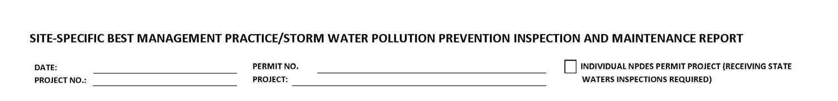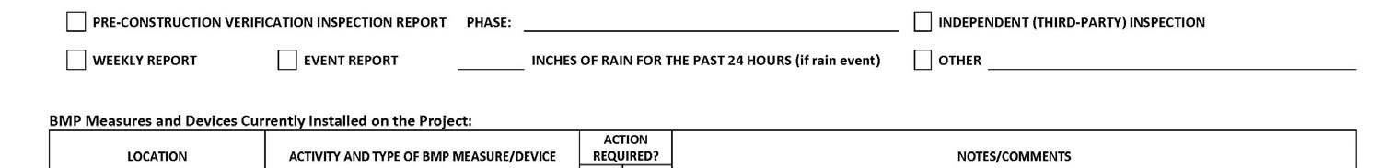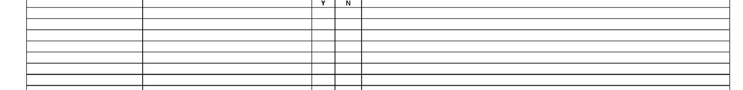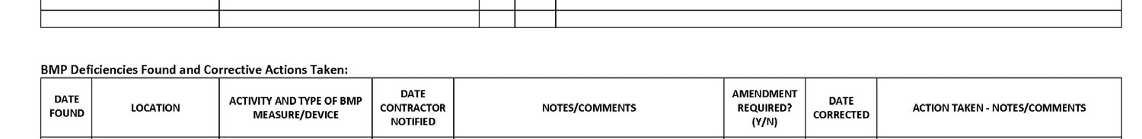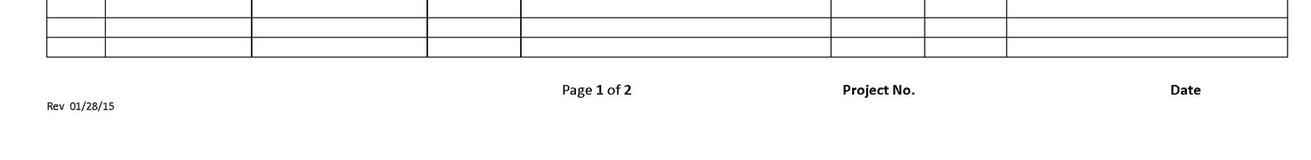
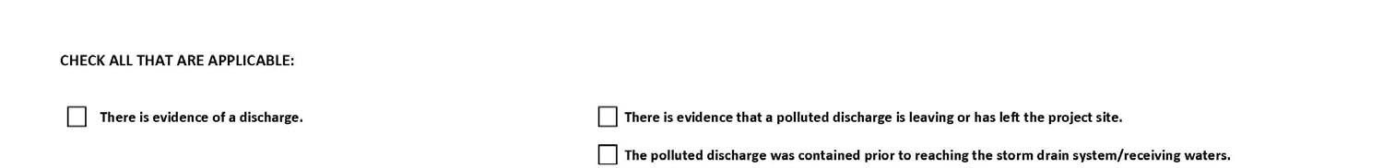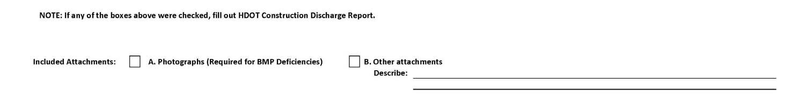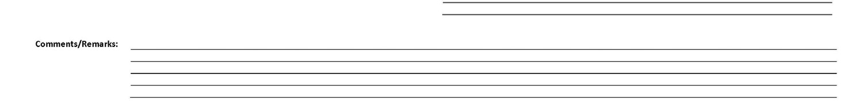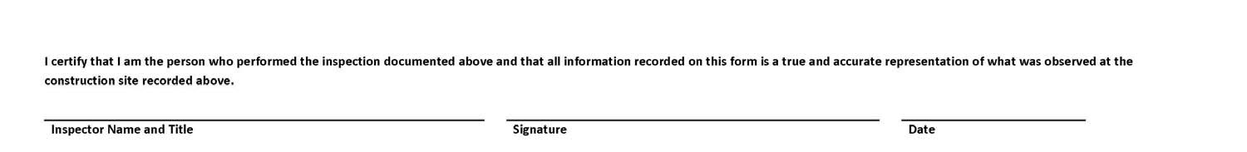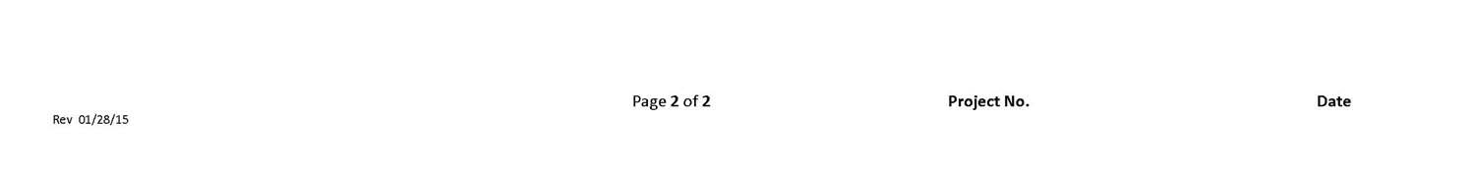

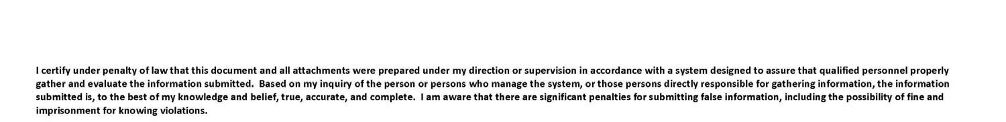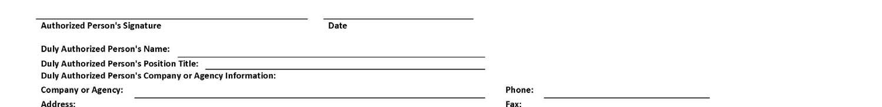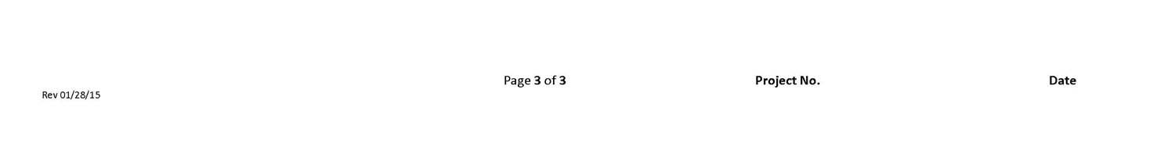

Attachment E2 – Corrective Action Reports (SWPPP Section 7.2.12)
Corrective Action Report

Section 10.1 “Corrective Actions” Defined
Corrective actions are actions taken in compliance with this section to:
- Repair, modify, or replace any storm water control used at the site
- Clean up and properly dispose of spills, releases, or other deposits
- Remedy a permit violation

Section 10.2.1. Triggering Events
The following are triggers that require corrective action be taken (this triggering condition is to be documented within 24 hours of discovering the occurrence):
- A required storm water control was never installed, was installed incorrectly, or not in accordance with the requirements in HAR Chapter 11-55, Sections 5 and/or 6.
- The Contractor/Engineer becomes aware that the storm water controls installed and being maintained are not effective enough for the discharge to meet applicable water quality standards or applicable requirements in HAR Chapter 11-55, Section 6.1. The Contractor shall notify the Engineer immediately. The Engineer will notify Army DPW Clean Water by the end of the next work day.
Date/time Engineer notified by Contractor
Date/time Army DPW Clean Water notified by Engineer
- One of the prohibited discharges below is occurring or has occurred:
  - Wastewater from washout of concrete
  - Wastewater from washout and cleanout of stucco, paint, form release oils, curing compounds and other construction materials
  - Fuels, oils, or other pollutants used in vehicle and equipment operation and maintenance
  - Soaps, solvents, or detergents used in vehicle and equipment washing
  - Toxic or hazardous substances from a spill or other release

Section 10.2. Requirements for Taking Corrective Actions
The Contractor shall complete corrective actions in accordance with the deadlines specified below. In all circumstances, the Contractor shall immediately take all reasonable steps to minimize or prevent the discharge of pollutants until a permanent solution is installed and made operational, including cleaning up any contaminated surfaces so that the material will not discharge in subsequent storm events. Immediately means the same day the condition is discovered, unless it is too late in the day, in which initiation of corrective action must begin on the following work day.
Following any of the above triggering events, the Contractor shall install a new or modified control and make it operational, or complete the repair, by no later than 7 calendar days from the time of discovery. If it is infeasible to complete the installation or repair within 7 calendar days, the Contractor shall document and submit to the Engineer, for his agreement, why it is infeasible to complete the installation or repair within the 7 calendar day timeframe and document a schedule for installing the storm water control(s) and making it operational as soon as practicable after the 7-day timeframe.
Date installation/repair completed or date/time prohibited discharge ceased

Reason it is infeasible to complete installation or repair within 7 calendar days and proposed
schedule (if applicable)

10.4.1. Initial Report (24 Hours)
Within 24 hours of discovering the occurrence of one of the triggering conditions in HAR Chapter 11-55, Section 10.2.1. at the site, the Contractor must complete the following:
- The nature of the condition identified
- The date and time of the condition identified and how it was identified

10.4.2. Final Report (7 Days)
Within 7 calendar days of discovering the occurrence of one of the triggering conditions in HAR Chapter 11-55, Section 10.2.1. at the site, the Contractor must complete a report of the following:
- Any follow-up actions taken to review the design, installation, and maintenance of storm water controls, including the dates such actions occurred

- A summary of storm water control modifications taken or to be taken, including a schedule of activities necessary to implement changes, and the date the modifications are
completed or expected to be completed

- Notice of whether SWPPP modifications are required as a result of the condition
identified or corrective action

Section 10.2.2. SWPPP Modification Due to Corrective Actions
Where corrective actions result in changes to any of the storm water controls or procedures documented in the SWPPP, modify the SWPPP accordingly within 7 calendar days of completing corrective action work.
- Date SWPPP modified should be indicated in the Amendment Log

Section 10.3 Corrective Actions Required by the Department of Health (DOH)
The Contractor shall comply with any corrective actions required by the department as a result of permit violations found during an inspection by DOH or EPA.
Was the Corrective Action triggered by a DOH/EPA inspection?
- Yes  No
- Date of DOH/EPA Inspection _

Section 10.4.3. Certification
The certifying person and duly authorized representative shall meet the requirements of Hawaii Administrative Rules 11-55, Appendix A, Section 15.
I certify under penalty of law that this document and all attachments were prepared under my direction or supervision in accordance with a system designed to assure that qualified personnel properly gather and evaluate the information submitted. Based on my inquiry of the person or persons who manage the system, or those persons directly responsible for gathering the information, the information submitted is, to the best of my knowledge and belief, true, accurate, and complete. I am aware that there are significant penalties for submitting false information, including the possibility of fine and imprisonment for knowing violations.

Section 10.4.4. Corrective Action Report

NOTE: Corrective Actions shall be documented in the Site-Specific Best Management
Practice/Storm Water Pollution Prevention Inspection and Maintenance Report, See Attachment E1.

Attachment E3 – Construction Discharge Report Form (SWPPP Section 7.2.12) Rev. 1/28/15
(See Next Pages)

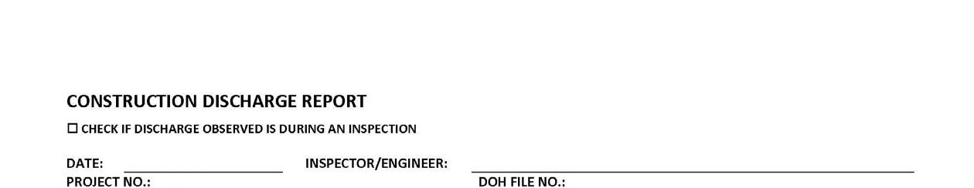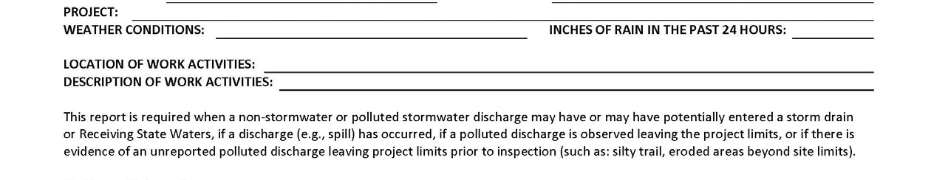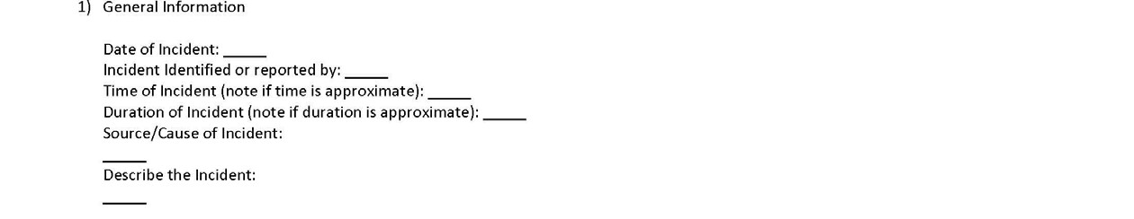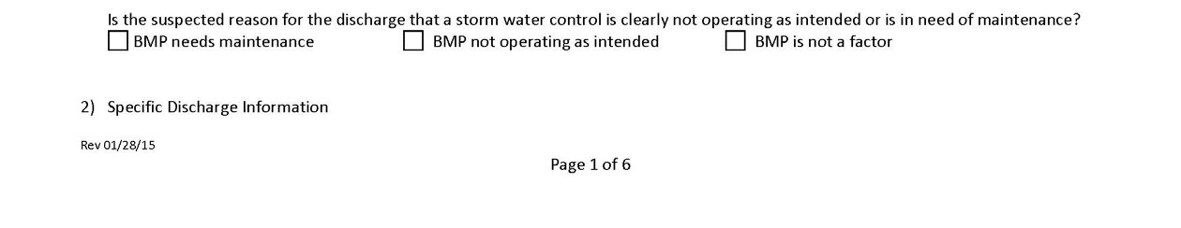
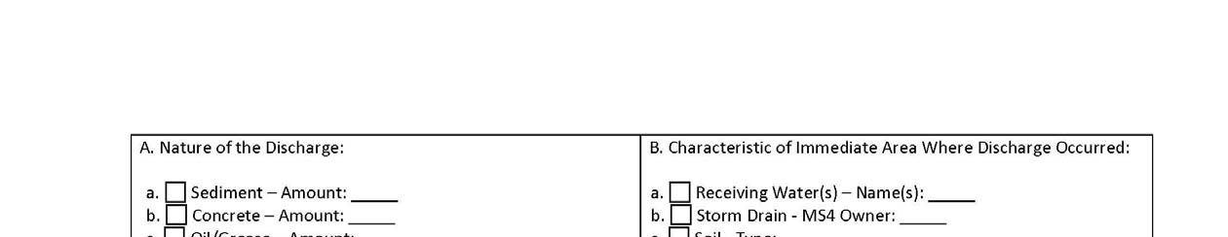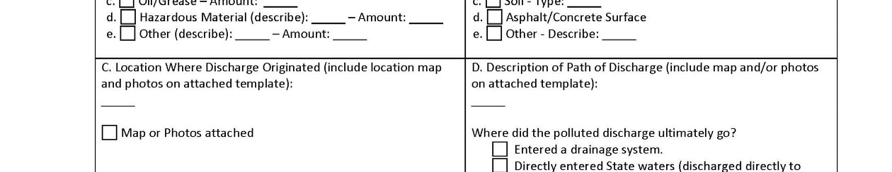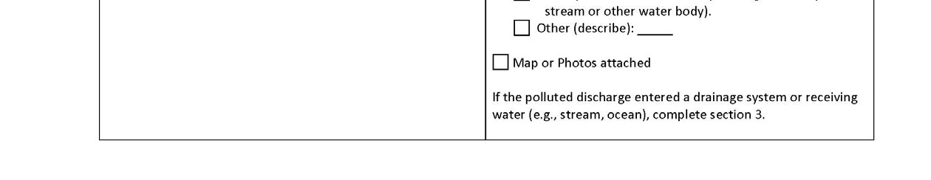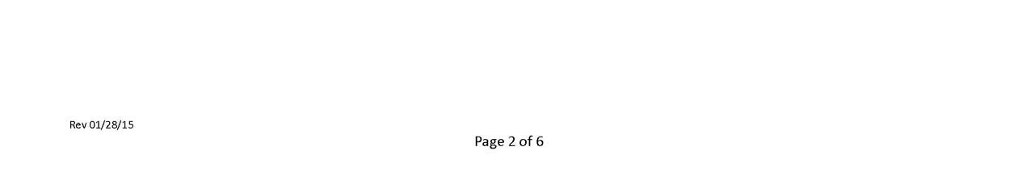
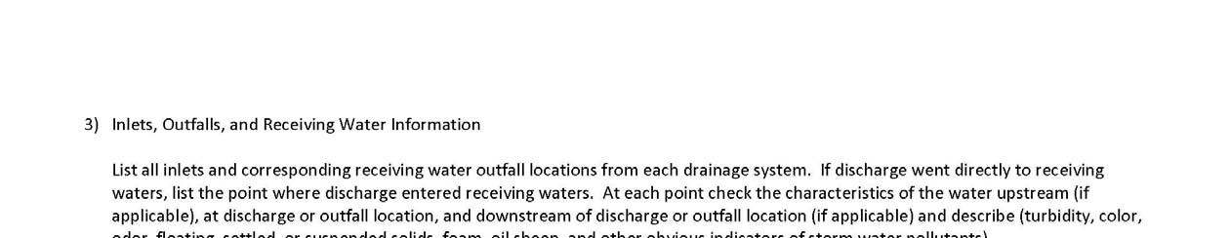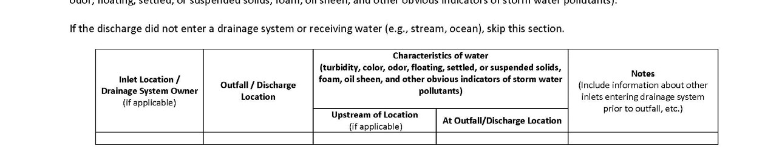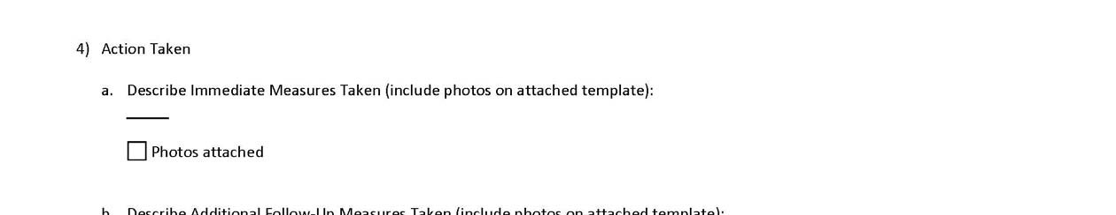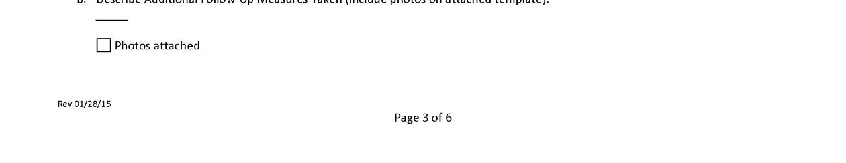
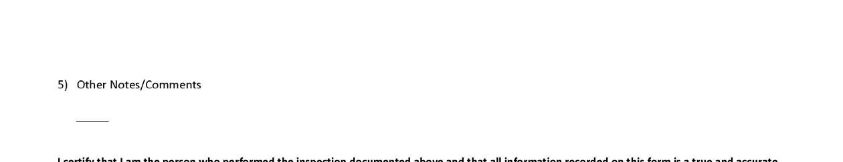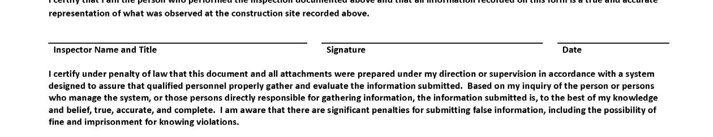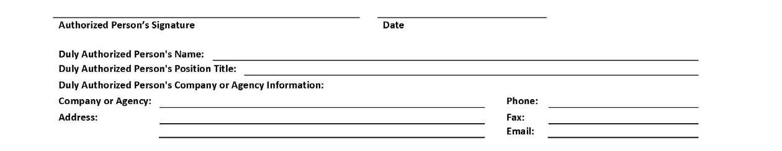
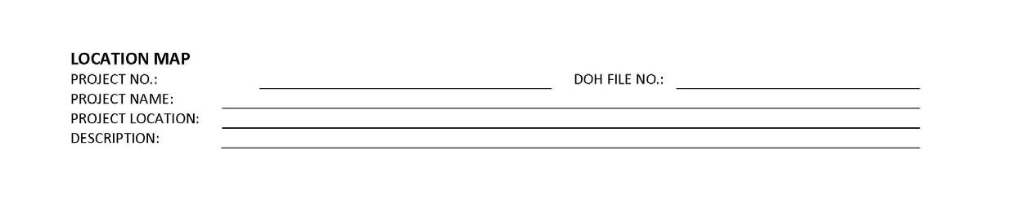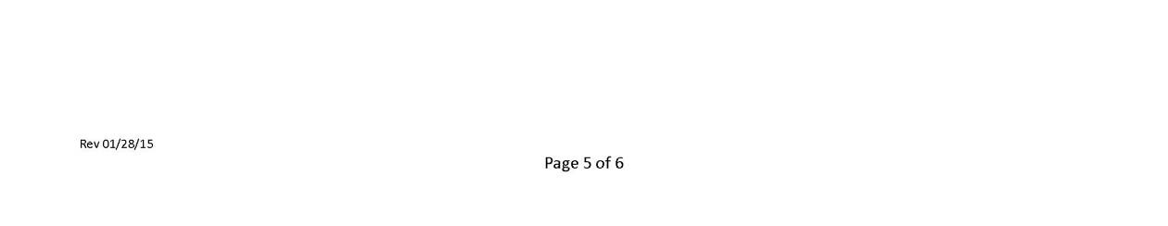
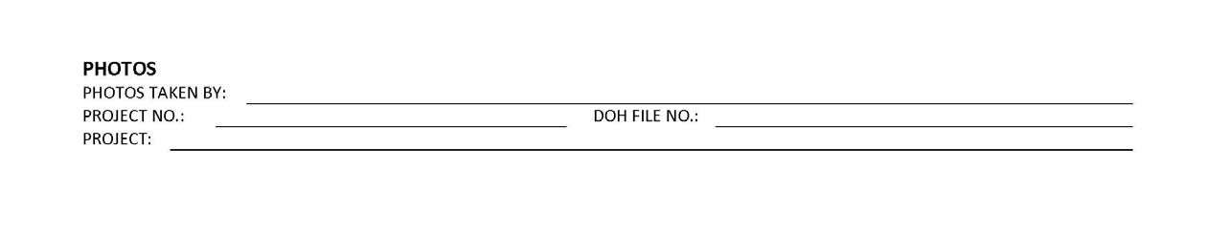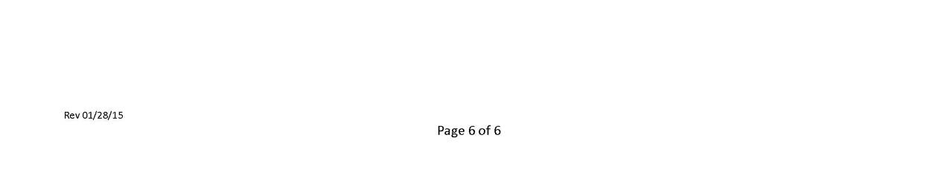

Attachment E4 – Monthly Compliance Report

Monthly Compliance Report

A Monthly Compliance Report is required to be completed within 2 working days of the end of the month. This report must be kept on-site and made available by the end of the next business day when requested by DOH. The following is required to be addressed in the Monthly Compliance Reports and include attachments as necessary.

- Any instances of non-compliance or corrective actions

If the activity is in compliance and none of the information on file with the department requires updating, or there were no incidences of non-compliance, preparation of the monthly compliance information is still required which states:
- No changes, updates, or any incidences of non-compliance to report.

The certifying person and duly authorized representative shall meet the requirements of the contract documents. The certifying person or duly authorized representative is required to sign the Monthly Compliance Reports with the following certification statement:

I certify under penalty of law that this document and all attachments were prepared under my direction or supervision in accordance with a system designed to assure that qualified personnel properly gather and evaluate the information submitted. Based on my inquiry of the person or persons who manage the system, or those persons directly responsible for gathering the information, the information submitted is, to the best of my knowledge and belief, true, accurate, and complete. I am aware that there are significant penalties for submitting false information, including the possibility of fine and imprisonment for knowing violations.

MONTHLY COMPLIANCE REPORT

Reporting Month/Year:
Project Name:
Location/Address:
DOH NGPC File No.: Project No.:
County/Island: Acreage Disturbed (acres):
Construction Start Date: Percent of Work Completed (%):

This form must be completed within 2 working days of the end of the month and must be kept on‐site and made available by the end of the next business day when requested by DOH. In addition, this form is required to be submitted to DOH with the Notice of Cessation at the completion of the project.

- BMP Deficiencies and Associated Corrective Actions
Date Found | Location | Activity and Type of BMP  Measure/Device | Date  Contractor Notified | Notes/Comments | Date Corrected | Action Taken

- Discharges This Month
Date  Discharge  Occurred | Outfall | Receiving Waterbody Discharged To | Date DOH Notified | Notes

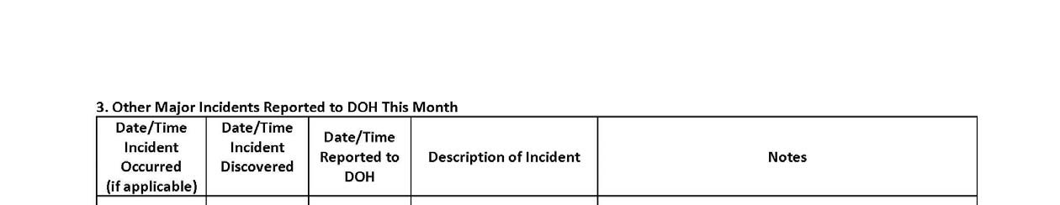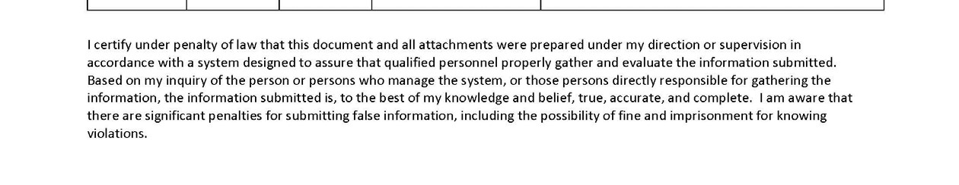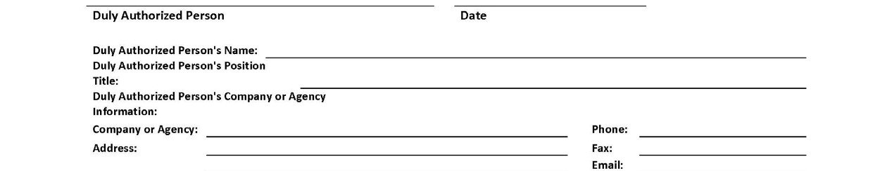

Attachment F – Spill Prevention and Response Procedures (SWPPP Section 7.2.11.1)
Spill Prevention and Control Plan (WM-4)

Emergency Spill Response Plan

Procedures for expeditiously stopping, containing, and cleaning up spills, leaks, and other releases.

Spill Coordinator
The Contractor shall appoint a Primary and Secondary Emergency Spill Response Coordinator who will be responsible for the reporting of spills, coordinating contractor personnel for spill cleanup, subsequent site investigations, and associated reports. In the event of a spill, the Emergency Spill Response Coordinator will be responsible for determining the extent of the containment/isolation area and cleanup methods. Include Names, positions, and emergency contact information.
The Contractor shall make contact with a Spill Cleanup Emergency Response Contractor prior to start of construction to provide sufficient information for the spill contractor to be prepared should they receive a call in the event of an emergency.

Immediate Response
All spills regardless of size must be reported to the Emergency Spill Response Coordinator and the Army DPW Spill Line/Project Engineer/Construction Inspector. The person observing the incident will take the following actions:
- Assess the safety of the situation (including the risk to the surrounding public).
- Alert nearby personnel and secure the immediate area for safety.

If the person is aware the chemical spilled is not toxic or a known petroleum product do the following:
- Make every effort to remove potential ignition sources and stop the source of the spill.
- Clean the spill using absorbent materials available on-site. Do not hose down or bury spills. Remove and properly dispose of cleanup materials.
- Promptly notify the Emergency Spill Response Coordinator. Report name, the spill location, material spilled, and the extent of the incident.

Upon learning of the spill, the Emergency Spill Response Coordinator will implement the following measures:
- Assess the safety of the situation (including the risk to the surrounding public).
- If the source of the spill is toxic or unknown, immediately notify the Fire Department and ask for assistance from the HAZMAT team.
- Report the spill to Army DPW Spill Line at 656-6111 during normal business hours, or 656-3272 afterhours
- Secure the area by stopping traffic if necessary and install barricades or safety fencing around the area. •If safe to do so, prevent hazardous material from entering the stormwater or sewer system or any waterbodies by covering/blocking any drains in the spill area, and providing containment BMPs to either prevent stormwater from contacting hazardous material or contain commingled stormwater.
•If safe to do so, absorbent materials will be applied to the spill area. Contaminated soils and vegetation will be excavated and temporarily placed on and covered by plastic sheeting or in an appropriate container or surrounded by impermeable lined berms in a containment area a minimum of 100 feet away from any wetland or waterbody, until proper disposal is arranged.
- Notify appropriate agencies as required by Federal, State, and local regulations.
•For petroleum spills, provide notification if the release meets any of conditions the below:
  - Greater than 25 gallons
  - Not cleaned within 72 hours
  - Enters a storm drainage system or state waters
- Arrange for proper disposal (including contaminated personal protective equipment and/or cleanup supplies) in accordance with Federal, State, and local regulations and Manufacturer’s instructions if known.
- If a spill is beyond the scope of on-site equipment and personnel, contact the Spill Cleanup Emergency Response Contractor to further contain and clean up the spill.
- Notify the Army DPW Spill Response Line, Project Engineer, and Construction Inspector.

Contents of the Spill kits shall be determined by the Contractor based on the anticipated type and quantity of hazardous material to be stored/used on-site. The kit should contain at minimum:
•55 gallon drum with lid
•absorbent pads (50)
•absorbent socks (12)
•absorbent pillows (5)
•1 pair goggles or face shield
•1 pair elbow length gloves
•1 disposable apron
•disposable bags with ties (3)
•Include additional materials such as Absorbent Skimmers or Booms for work adjacent or over State Waters as needed.
•Include additional materials as necessary to secure the spill area.

Procedures for notification of appropriate facility personnel, emergency response agencies, and regulatory agencies where a leak, spill, or other release containing a hazardous substance or oil in an amount equal to or in excess of a reportable quantity consistent with HAR Chapter 11-55 subsection 5.3.4. and established under either 40 CFR Part 110, 40 CFR Part 117, or 40 CFR Part 302, occurs during a 24-hour period (7.2.11.1.b).
- Contact information must be in locations that are readily accessible and available.
- The Contractor shall take all reasonable measures to protect human health and the environment.
- For emergencies or life-threatening situations, call 911 first.

- Notify responsible parties listed below as required and immediately notify the Army DPW Spill Response Line of the incident. The notification shall also include the identity of the pollutant sources and the implemented control or mitigation measures. Notify other agencies as required by Federal/State/Local laws. List additional agencies or personnel below as required.

    - Owner Contact/Emergency Contact Number: (Construction Engineer/Project Engineer/Construction Inspector)

[INSERT NAME] (Construction Engineer) - [INSERT PHONE NO. XXX-XXXX]
[INSERT NAME] (Project Engineer) - [INSERT PHONE NO. XXX-XXXX]
[INSERT NAME] (Supervising Inspector) - [INSERT PHONE NO. XXX-XXXX]

    - Authorized Representative/ Emergency Contact Number: [INSERT Contractor or designated representative who can contact Authorized Representative]

    - Contractor/ Emergency Contact Number: [INSERT Contractor Emergency Contact]

    - Army Directorate of Public Works (DPW) Spill Response Line
During regular working hours:…………………………..………………………..808-656-6111
After hours:……………………………………………………………………….. 808-656-3272

- County Fire Department/Police……………………………………………… 911
6. Spill Cleanup Emergency Response Contractor {INSERT Spill Cleanup Emergency Response Contractor}……………………..XXX-XXX-XXXX
- If required, fill in and follow the requirements of the Corrective Action Report.

Attachment G – Waste Management Procedures (SWPPP Section 7.2.11.2)
Waste Management Procedures

The Contractor shall submit the DOH “Solid Waste Disclosure Form for Construction Sites” to the Engineer within 30 calendar days of contract execution. The form can be downloaded at:
http://health.hawaii.gov/shwb/files/2013/06/swdiscformnov2008.pdf

Provide a copy of all the disposal receipts from the facility permitted by the Department of Health to receive solid waste to the Engineer monthly, this should also include documentation from any intermediary facility where solid waste is handled or processed, or as directed by the Engineer.

Solid Waste Management (WM-5)

Sanitary/Septic Waste Management (WM-9) Hazardous Waste Management (WM-6)

ADD SIGNED SOLID WASTE DISCLOSURE FORM – Include the solid wastes produced by your Sub-contractors, all solid waste should be accounted for.
[Edit as applicable] Litter Management Plan
Project Name
- Construction site preparations.
Before the start of construction activities, during the mobilization process, proper litter waste receptacles will be located at the construction site. Litter receptacles will be placed within the boundaries of the project right-of-way or within a project related vehicle onsite. Construction debris receptacles that accept mixed reuse may also act as litter control receptacles.
- Daily Construction Site Litter Prevention Activities.

  - Pre-Construction activities litter prevention and control activities.

    - At the start of each work day, the active work areas of the construction site(s) will be inspected for litter debris.
    - Litter debris found will be collected and properly sorted into the proper debris receptacle.
    - Litter will be collected whether or not it was sourced from the job site and construction related activities.
    - After collection, litter will be disposed of in appropriate waste containers and all practices outlined in the Waste Management Plan will be followed.
    - Waste containers will be inspected regularly to prevent overfilling.

  - Post-Construction Site Litter Prevention Activities

      - At the end of each work day, the active work areas of the construction site(s) will be inspected for litter debris.
      - Litter debris found will be collected and properly sorted into the proper debris receptacle.
      - Litter will be collected whether or not it was sourced from the job site and construction related activities.
      - After collection, litter will be disposed of in appropriate waste containers and all practices outlined in the Waste Management Plan will be followed.
      - Waste containers will be inspected regularly to prevent overfilling.

  - BMPs and Litter Control

• Construction Site BMPs will be inspected for litter debris when conducted weekly BMP inspection or after a significant rain event as litter debris may reduce the performance of BMPs.

Attachment H – Contingency Plan

[Edit as applicable]Provide a contingency plan that will be implemented to prevent or respond to a polluted discharge resulting from a severe storm or natural disaster. Include how the weather will be monitored, site will be secured, and who to notify.
SEVERE STORM CONTINGENCY PLAN

The following plan will be implemented by the General Contractor to prevent/respond to polluted discharges resulting from a severe storm or natural disaster. It is the General Contractor’s responsibility to abide by the following plan as well as any other binding plan, agreement, regulation, rule, law, or ordinance applicable.

All contactors associated with the following construction project: Project Name will follow this plan when a severe storm is either forecast or anticipated or as directed by the Engineer.

General Contractors shall:

- Regularly monitor local weather reports for forecasted and/or anticipated severe storm events, advisories, watches, warnings or alerts. The Contractor shall inspect and document the condition of all erosion control measures on that day prior, during, and within 24 hours after the event. The Contractor shall prepare for forecasted and/or anticipated severe weather events to minimize the potential for polluted discharges.

- Secure the construction site. Securing the site shall include at a minimum:
  - Removing or securing equipment, machinery, construction materials, and portable toilets. If portable toilets are to remain on-site, they shall be pumped the day prior to the event.
  - Cleaning up all construction debris. iii. Stopping scheduled material deliveries.
  - Locating and turning off jobsite utilities, including electricity, water, and gas.
  - Implementing all Best Management Practices detailed in the SWPPP. This includes BMPs for materials management, spill prevention, and erosion and sediment control. To protect human health, the Engineer will use their discretion as to whether to remove BMPs which may impede flow into inlets causing ponding on the roadway. These changes shall be noted on the SWPPP.
  - Work crews shall finalize securing the project site, and evacuate until the severe weather condition has passed.

- Upon return to the Site, all BMPs shall be inspected, repaired and/or re-installed as needed. If repair or reinstallation of removed BMPs is necessary, it shall be initiated within 24 hours of the inspection. Note the changes on the SWPPP. To facilitate repair or replacement, the Contractor shall be required to store surplus material on the project site if the site is located where replacement materials will not be readily available.

- When there has been a discharge which violates Hawaii Water Pollution rules and regulations OR there is an imminent threat of a discharge which violates Hawaii Water Pollution rules and regulations and/or endangers human and/or environmental health, the Engineer shall, at a minimum, execute the following steps:
i. Assess whether construction needs to stop or if additional BMPs are needed to stop or prevent a violation.
ii. Direct the Contractor to take all reasonable measures to protect human health and the environment.
iii. Notify responsible parties listed below and immediately notify Army DPW of the incident. The notification shall also include the identity of the pollutant sources and the implemented control or mitigation measures.
      - Owner Contact/Emergency Contact Number: XXX, XXX-XXXX
      - Owner Contact/ Emergency Contact Number:
XXX, XXX-XXXX
      - Contractor/ Emergency Contact Number:
XXX, XXX-XXXX
      - Army DPW Spill Response Line
(During regular working hours): 808-656-6111 (After hours): 808-656-3272
    - Document corrective actions, take photographs of discharge and receiving waters.

    - Evaluate the effectiveness of the construction BMPs in the Site- Specific Construction Best Management Plan in relation to the design storm. If the storm was less than the design storm and BMPs were ineffective, revise BMPs to prevent future discharges of a similar nature.

Attachment I – SWPPP Amendment Log
AMENDMENT LOG
Each Amendment must be signed by the authorized representative authorizing the changes.

Project Name: SWPPP Contact:
Amendment No. | Description of the Amendment | Date of  Amendment | Amendment  Prepared by  [Name(s) and Title]

Add rows as needed.

Attachment J – Emergency Related Projects, Departures from Manufacturer’s Specifications for Fertilizers Containing Nitrogen or Phosphorus, Buffer Documentation, Documentation of Compliance with UIC Requirements, Other State/Federal/County Permits, & Other Information as Requested by the Director (SWPPP Sections 7.2.3, 7.2.9, 7.2.14, 7.2.15, and 7.2.16)

Attachment K – Post-Authorization Additions to the SWPPP

